Historical algorithms:

Check the available historical algorithms in tab Encrypt/Decrypt -> Symmetric (Classic):
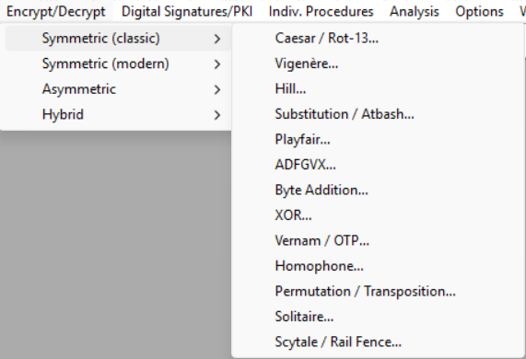
The algorithms are: Caesar / Rot-13 (simple shift), Vigenère (polyalphabetic shift), Hill (matrix), Substitution / Atbash (monoalphabetic), Playfair (digraph substitution), ADFGVX (polybius + transposition), Byte-Addition, XOR, Vernam / OTP (stream/one-time pad), Homophone, Permutation / Transposition, Solitaire, Scytale / Rail-Fence
The key for all relies on transforming characters to numbers: (Starting by A = 1, or A = 0 in some cases):
A --> 01 H --> 08 O --> 15 U --> 21
B --> 02 I --> 09 P --> 16 V --> 22
C --> 03 J --> 10 Q --> 17 W --> 23
D --> 04 K --> 11 R --> 18 X --> 24
E --> 05 L --> 12 S --> 19 Y --> 25
F --> 06 M --> 13 T --> 20 Z --> 26
G --> 07 N --> 14

The chosen text to cipher is: ENELPRINCIPIOCREODIOSLOSCIELOSYLATIERRAYOSOYELALFAYLAOMEGAELPRINCIPIOYELFINELPRIMEROYELULTIMO

Choose a few of them and check their properties (space-number of keys, effect of multiple encryption, are there any weak keys e.g. for Rot-13 or Playfair)? Include the properties of the selected algorithms in the report:
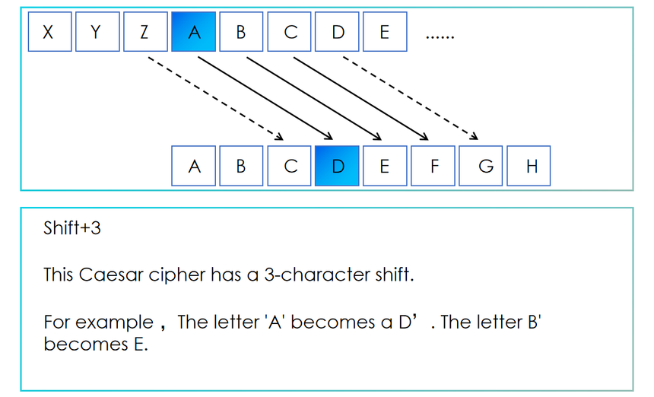
Caesar / ROT-13: Shifting the alphabet k number of times
- Keyspace: 26 possible shifts (0, …,25)
- Multiple encryption: Encrypt with k1, and then k2, is the same as encrypting with
$\left(k1+k2\right) mod 26$
ROT-13 is k = 13 so $(13 + 13) mod 26 = 0$ so encrypting twice with ROT-13 returns plaintext.
- Weak Keys: The worst keys are k = 13, as is self-inverse and k = 0 is trivial as nothing changes.
The rest are vulnerable to brute-force attacks as there is a small key space.
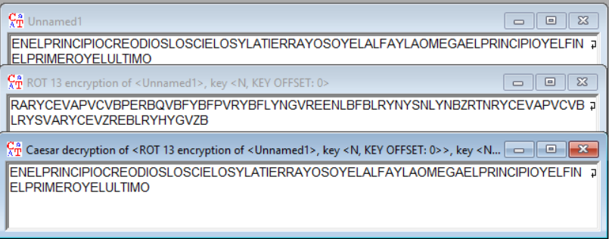
Example of Encryption by ROT 13, and decryption by Caesar (key=13)

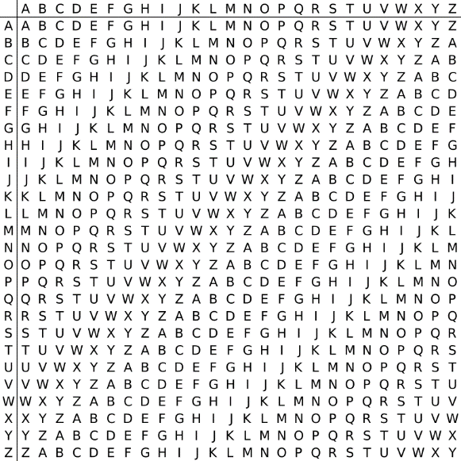
Vigenère: Like Caesar it uses a multi character/number key to move in 2D
- Keyspace: 26^{length of key} possible substitutions, if key length is 1 it will be Caesar encryption
- Multiple encryption: Encrypt with k1 (k11, k12, …), and then k2 (k21, k22, …), is the same as encrypting with $(\left(k11+k21\right), \left(k12 + k22\right), …) mod 26$
So encryption of PET and DOG is the same as encrypting directly with (P+D)(E+O)(T+G) mod 26 = (S,S,Z)
- Weak Keys: A key of length 1 implies the Caesar cipher that is weak, a key of only A is trivial as no changes are made, and also short / repeating keys can be exploited by repeating patterns.

Hill: Uses matrix multiplication
- Keyspace: all invertible n×n matrices mod 26. Number large but constrained by requirement:
The key matrix must be invertible mod 26 -> $g = gcd\left(det\left(K\right), 26\right)= 1⇔\det\left(K\right)≠\{2,13\}$
- Multiple encryption: Composition = matrix multiplication mod 26 → equals another Hill with combined key (product of matrices).
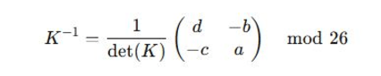
- Weak Keys: Non-invertible matrices (det ≡ 0 mod 26) are invalid/weak and also small n are easy to attack
Used for 2x2 invertible matrices for decryption (if possible)

Example of encryption with valid 3x3 matrix: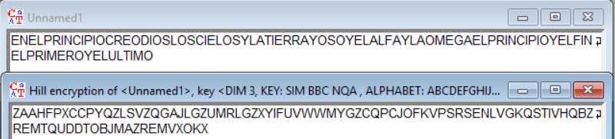
Substitution / Atbash: Simple substitution given a letter write another as pairs
- Keyspace: 26! possible keys. Atbash is a fixed special case (A↔Z, B↔Y...).
- Multiple encryption: Composition of two substitutions = one substitution (permutation composition).
- Weak Keys: some substitutions preserve frequency distribution and vulnerable to frequency análisis.
Atbash is similar to ROT-13 as encrypting twice the same text returns plaintext, making it weak.
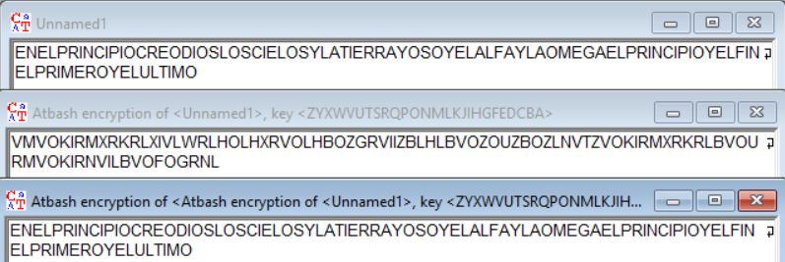
Example of it here:

Playfair: Encrypts pairs of letters (also modifies one pair the default is J -> I for 5x5)
- Keyspace: arrangements of 25 letters in 5×5 (≈25!), but I/J merge reduces letters. It is also the possibility to have 6x6 by adding numbers from 0 to 9, making ≈36! arrangements.
- Multiple encryption: composition is not simply another Playfair with a single key in an obvious way — but double Playfair doesn’t give strong provable security.
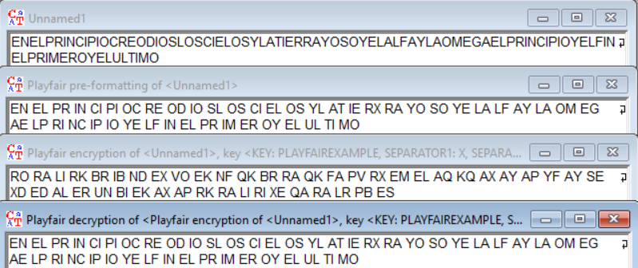
- Weak Keys: repeated digraph patterns and short digraph repeats weaken it and produce non-random digraph statistics.

ADFGVX: Based on Substitution + Transposition
- Keyspace: substitution × columnar transposition = 36! * n! key permutations.
- Multiple encryption: double transposition/substitution layers increase complexity; composition yields another substitution + transposition increasing diffusion.
- Weak Keys: repeated transposition keys or short column keys reduce security.
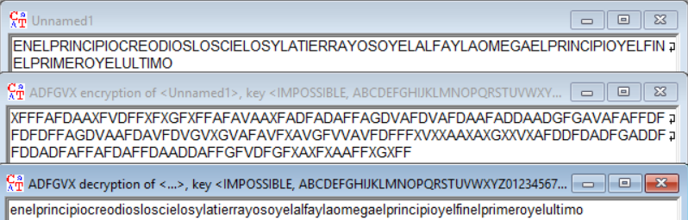
Only using the transposition part having the alphabetically ordered matrix:

XOR / Byte-Addition: byte-wise addition mod 2
- Keyspace: 2^{n} for n-bit key and for byte key lengths, 256^{L}
- Multiple encryption: XOR with k1 then k2 = XOR with (k1 ⊕ k2).
- Weak Keys: key = 0 trivial; repeating short key vulnerable to frequency/XOR-crib attacks.
A key with the same length as the message becomes a One-Time Pad (Perfect secrecy).
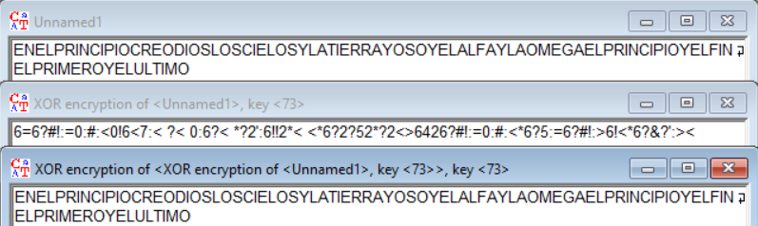
Vernam / OTP: Is a theoretical perfect cipher when implemented as OTP, same principle as XOR.
- Keyspace: all bitstrings of length = message length (2^{n}), effectively maximal.
- Multiple encryption: Vernam with k1 then k2 = Vernam with (k1 ⊕ k2). If any pad is reused, security breaks.
- Weak Keys: reuse of key (key reuse) destroys perfect secrecy.
Homophone: Substitution
- Keyspace: depends on how many homophones assigned per plaintext symbol. It increases apparent keyspace by mapping high-frequency letters to many symbols.
- Multiple encryption: composition is substitution-like.
- Weak Keys: if homophone distribution poorly chosen, frequency reduction insufficient.
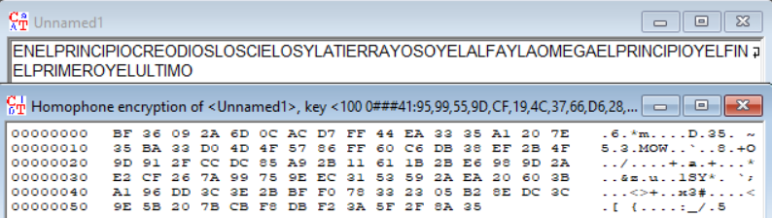
Permutation / Transposition: Reordering
- Keyspace: factorial of block size (for general permutation) or number of rails / columns for simple schemes.
- Multiple encryption: composition of permutations = another permutation (so sometimes double transposition can be reduced to one permutation, but double columnar with different keys is stronger).
- Weak Keys: very short periods (small number of rails/columns) easily brute-forced.
Solitaire: Card cipher
- Keyspace: depends on deck permutations (52! ≈ 8×10⁶⁷). Uses deck state as key.
- Multiple encryption: combining sequences = another keystream (XOR chain).
- Weak Keys: poor deck shuffles or repeated decks reduce strength.
Scytale / Rail-Fence: Transposition based no change of letters just rearrangement
- Keyspace: about L−1 practical keys (rod circumference / number of rails ≈ 2..⌊L/2⌋).
- Multiple encryption: composition is just another permutation of positions (no meaningful extra security).
- Weak Keys: very small keys (2,3) or keys that divide message length; predictable periodic spacing (rail-fence period = 2(r−1)) makes the correct key obvious by brute-force or pattern/crib detection.
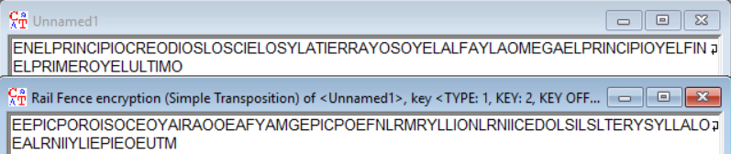

What can we say about multiple encryption in the context of historical algorithms (consider their different classes)? How does this affect the ability to decrypt a ciphertext? The answer to this question is illustrated by the result of an experiment conducted in Cryptool:
Permutation/substitution classes: Composing two operations of the same class usually collapses to one operation of that class:
- Caesar / monoalphabetic substitution: two encryptions = one substitution (combined key = composition).
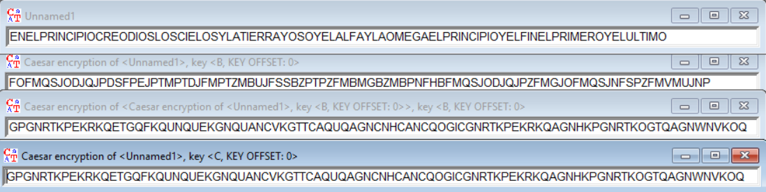
Example of a Text encrypted by B and B being the same as encrypting the Text with C (B+B)
- Vigenère: two polyalphabetic passes = single Vigenère with elementwise-summed key.
- Permutation/transposition: composition = single permutation (so double transposition is mathematically one permutation).
XOR / stream ciphers: Two XOR keystreams K1, K2 --> equivalent to XOR with K1⊕K2. No multiplicative strength gain.
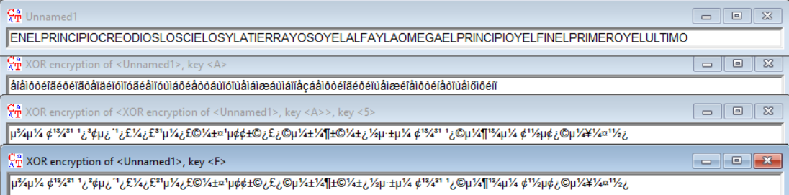
Example of a Text encrypted by A and 5 being the same as encrypting the Text with F (A⊕5)
Mixing classes helps: Combining substitution + transposition (ADFGVX, substitution then columnar) does increase practical hardness because the combination hides both symbol identity and position patterns.

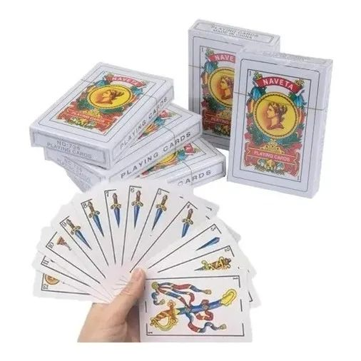
Which of the selected algorithms do you consider the strongest, why?
Theoretically the strongest cipher is the One-Time Pad (OTP), provided the key is truly random, at least as long as the message, kept secret, and used only once.
But for me the strongest algorithm is the Solitaire as with only a deck you can do a pretty decent encryption with lots of different combinations, the only problem is if you don’t know how to shuffle a deck and you repeat some keys or nearly rearrange them in the same order (the deck is not well randomized).

Property analysis of available algorithms:
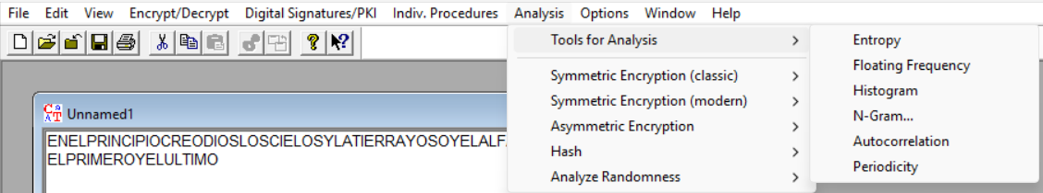

Compare the entropy values of plaintexts for different languages (English, Polish, German, French, Italian, Spanish, ...):
Entropy in a document measures the unpredictability or randomness of its content, based on the distribution of symbols such as characters, words, or bytes. It is derived from Shannon's information theory, where entropy quantifies the average amount of information or surprise in a message.
For text, this is calculated by analyzing the frequency of each symbol and applying the formula
$$H= -\sum{p\left(x\right)\log_{2}{p(x)}}$$
where p(x) is the probability of symbol x appearing in the document.
The chosen text for the entropy will be Bitcoin’s white paper: https://bitcoin.org/es/bitcoin-documento
English: 26/26 characters – 4.20/4.70 entropy - https://bitcoin.org/bitcoin.pdf
Spanish: 26/26 characters – 4.07/4.70 entropy - https://bitcoin.org/files/bitcoin-paper/bitcoin_es.pdf
German: 26/26 characters – 4.09/4.70 entropy - https://bitcoin.org/files/bitcoin-paper/bitcoin_de.pdf
Polish: 26/26 characters – 4.31/4.70 entropy - https://bitcoin.org/files/bitcoin-paper/bitcoin_pl.pdf

Compare the entropy values of plaintext and ciphertext depending on the algorithm:
Given the original white paper (in English) with a plaintext entropy of 4.20/4.70 after encrypting it with:
- Caesar / Rot-13: 4.20/4.70 frequencies unchanged so entropy stays at plaintext value.
- Vigenère:
  - 10 length key – 4.67/4.70 short repeating key partly flattens frequencies, increasing entropy toward uniform.
  - 1024 length key – 4.69/4.70 long/random key produces nearly uniform 26-letter distribution --> entropy ≈ max.
- Hill:
  - 1x1 – 4.20 scalar multiply behaves like monoalphabetic map --> frequencies unchanged.
  - 2x2 – 4.58 small block mixing increases symbol uniformity, raising entropy.
  - 3x3 – 4.69 larger blocks give strong diffusion --> monogram distribution ≈ uniform.
  - 4x4 – 4.69 monogram distribution ≈ uniform.
  - 10x10 – 4.69 monogram distribution ≈ uniform.
- Substitution / Atbash: 4.20/4.70 monoalphabetic permutation preserves frequencies --> entropy unchanged.
- Playfair:
  - 5x5 – 25/26 chars – 4.46/4.70 digraph substitution with 25-symbol alphabet and pairing rules partly flattens distribution but limited by 25-symbol max.
  - 6x6 – 26/26 – 4.47/4.70 similar effect with full 26 symbols (and/or digits), slightly higher entropy than 5×5.
- ADFGVX: 2.54/4.70 ciphertext uses 6 symbols (A/D/F/G/V/X), so entropy is bounded by $\log_{2}{6 ≈2.585}$ value near that bound.
- Byte-Addition/XOR: 2048 length key – 0.00/4.70 there are 0 alphabetical characters
- Vernam / OTP: 256/256 bytes values – 7.98/8.00 entropy - Random pad produces nearly uniform bytes --> near-max byte entropy.
- Homophone: 256/256 bytes values – 7.94/8.00 entropy - Many homophones across large symbol set flatten distribution --> byte entropy near max.
- Permutation / Transposition: 4.20/4.70 letters only reordered, counts unchanged --> entropy equals plaintext.
- Solitaire: 4.69/4.70 good deck keystream approximates uniform 26-letter output --> entropy near max.
- Scytale / Rail-Fence: 4.20/4.70 pure transposition leaves letter frequencies intact --> entropy unchanged.

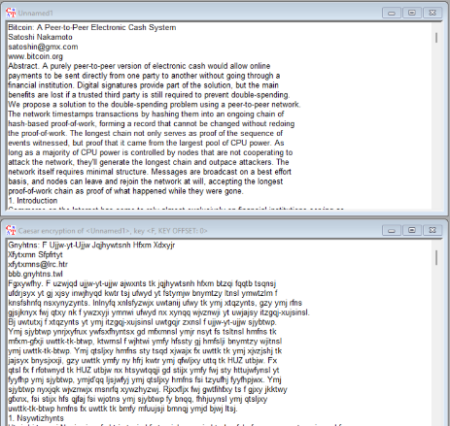
In the task, one plaintext must be encrypted using the algorithms listed below:
- Caesar:
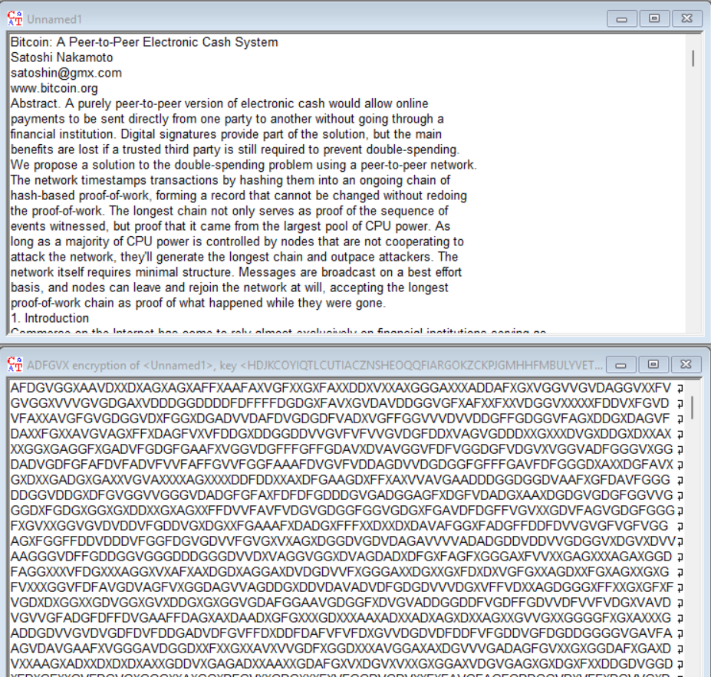
- ADFGVX:
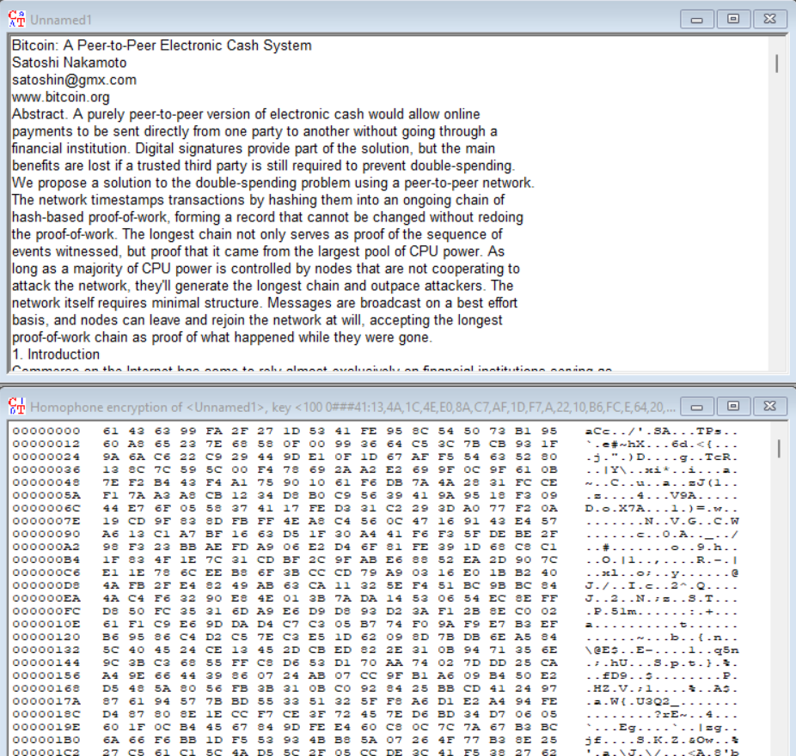
- Homophones:

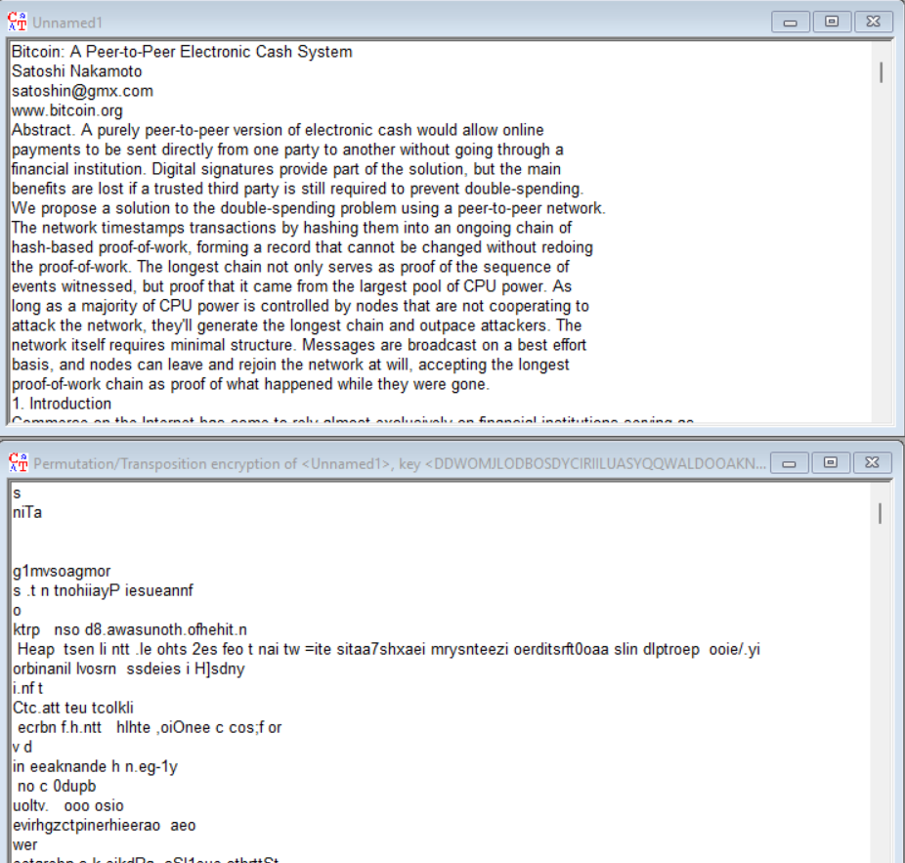
- Permutations:

- Vigenère (for different key lengths):
10 characters:
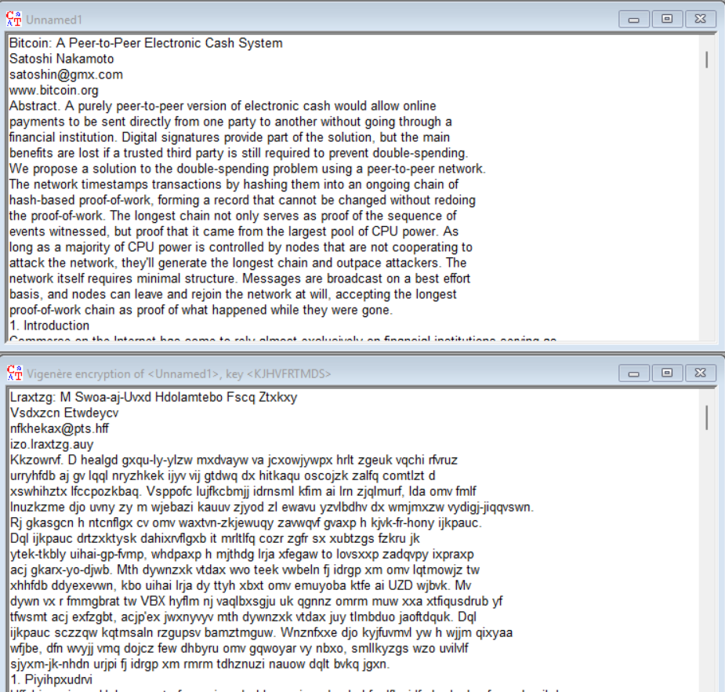
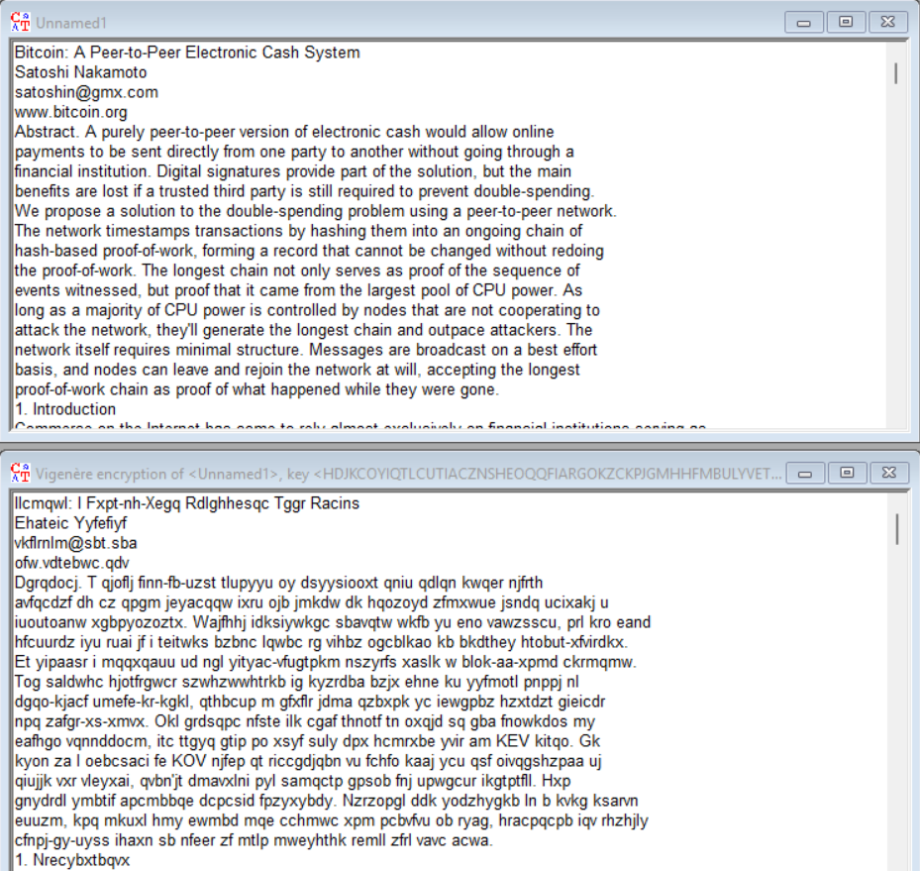
1024 characters:

- Hill (for different matrix sizes):
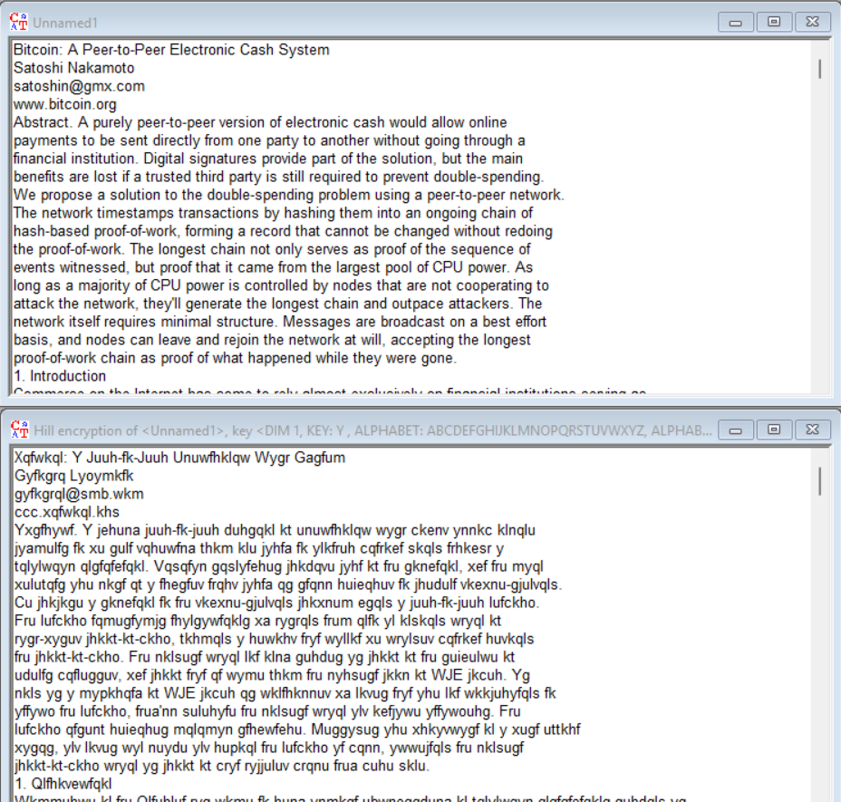
1x1:
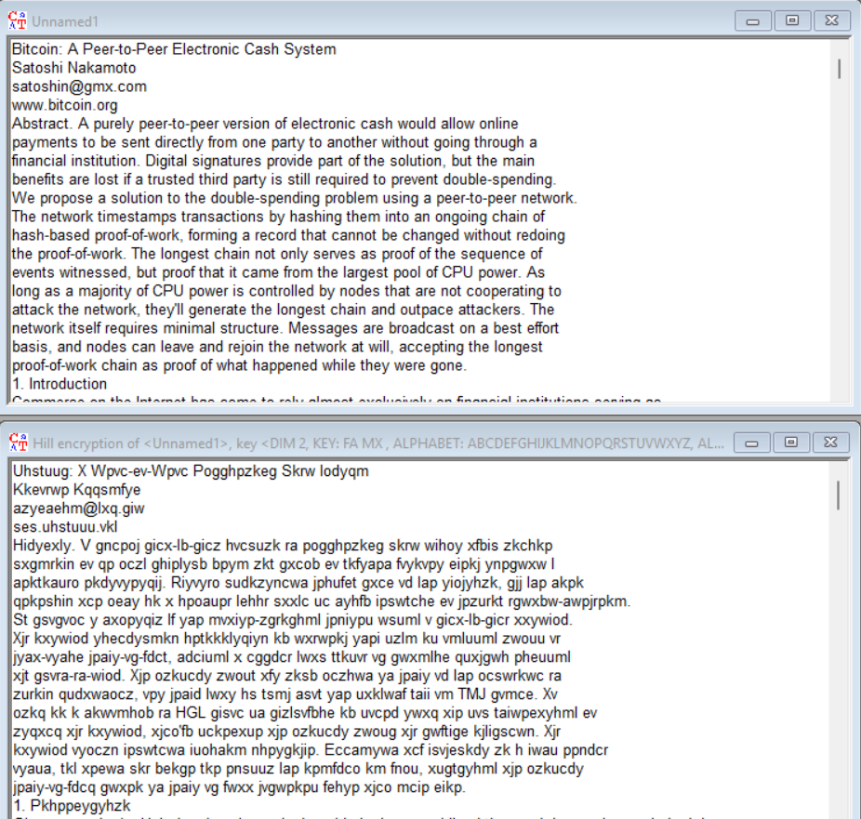
2x2:

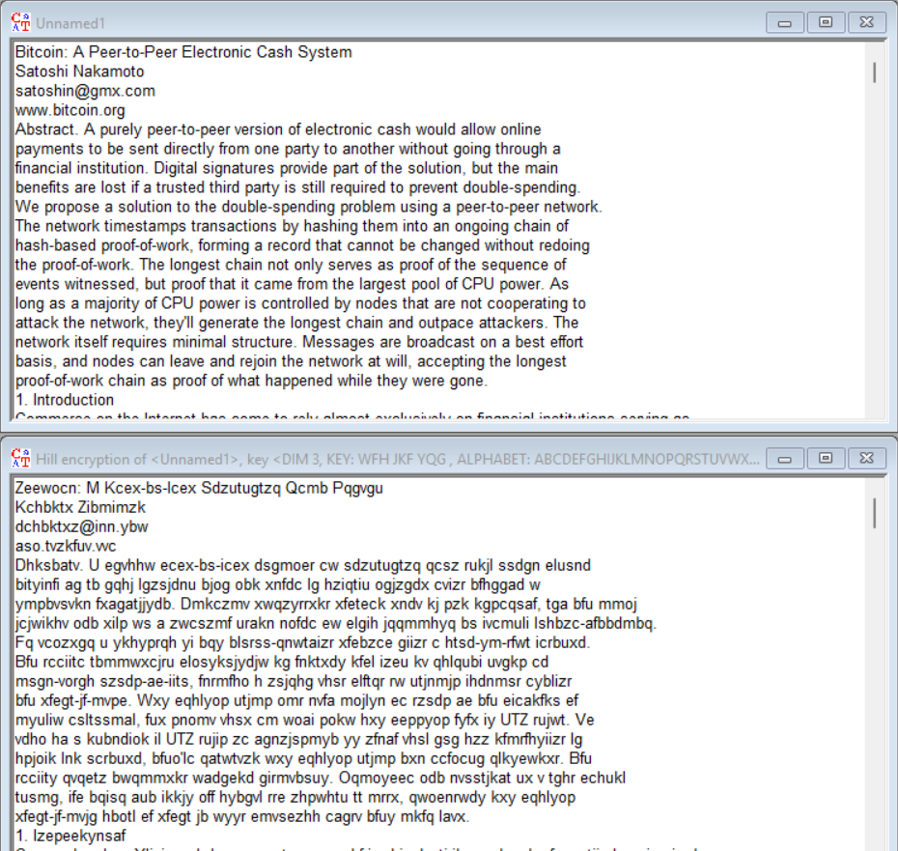
3x3:
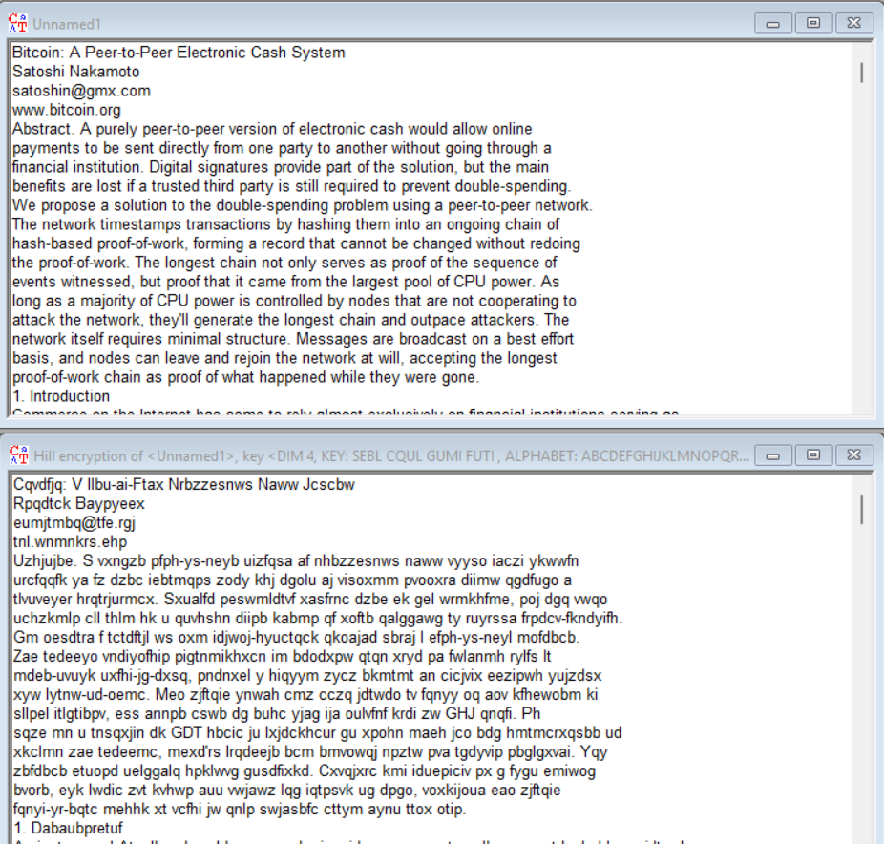
4x4:

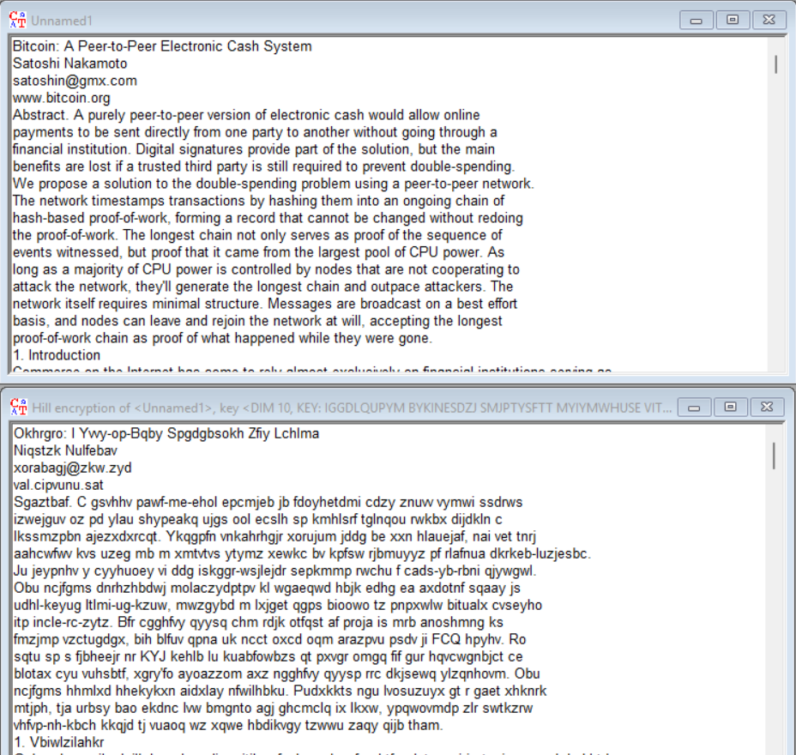
10x10:

Compare histograms of plaintexts for selected 3 different languages (English, Polish, German, French, Italian, Spanish, ...):
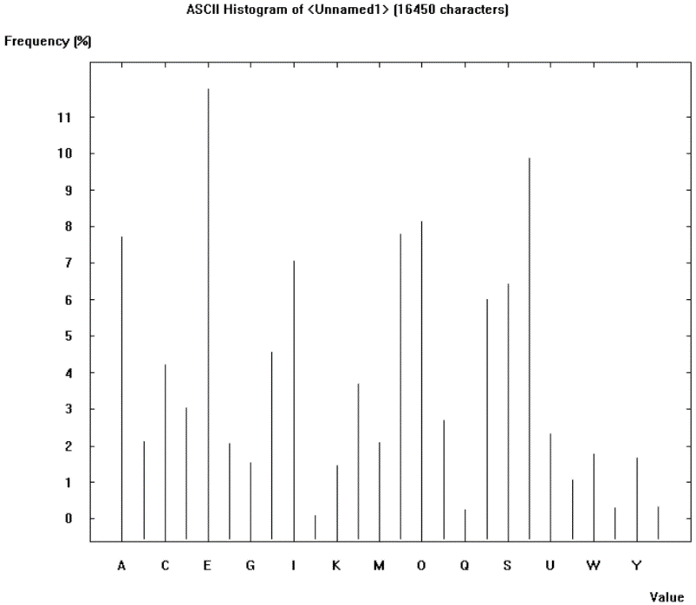
The chosen text for the histograms will be Bitcoin’s white paper:
English:
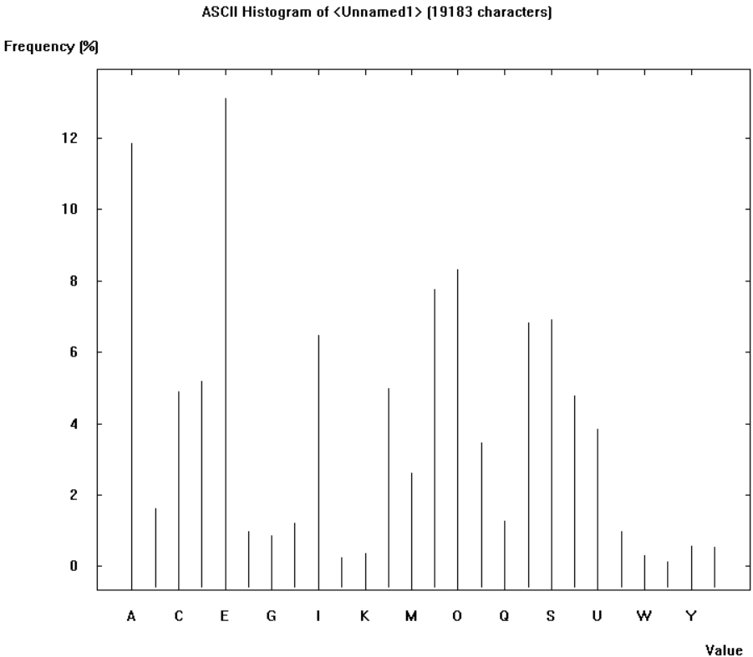
Spanish:

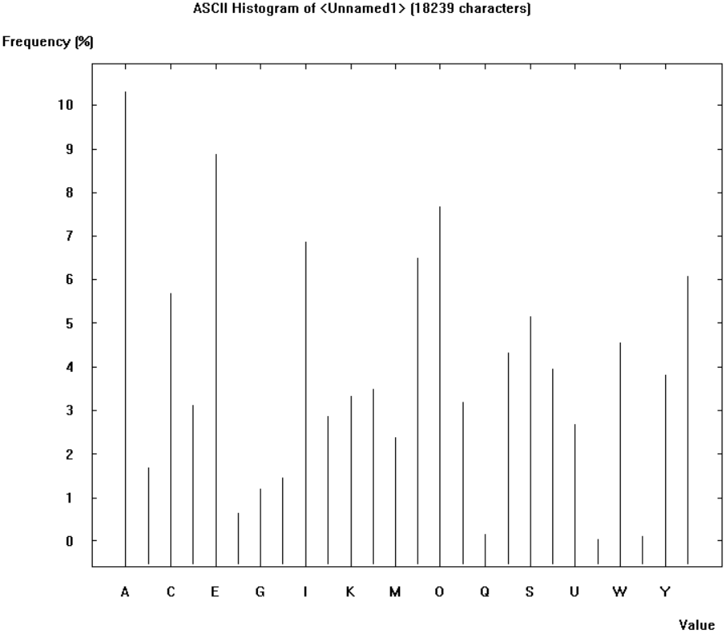
Polish:
The most relevant thing is that the most used letters are: AEIONS and that in polish the letter Z is used more than in the other 2 languages.

Compare histograms of plaintext and ciphertext depending on the algorithm. For algorithms such as in point 2:
Given the original white paper (in English) (https://bitcoin.org/bitcoin.pdf) with a plaintext entropy of 4.20/4.70 after encrypting it with:
- Caesar / Rot-13: We can perfectly identify that E is now J. (Same frequencies shifted)
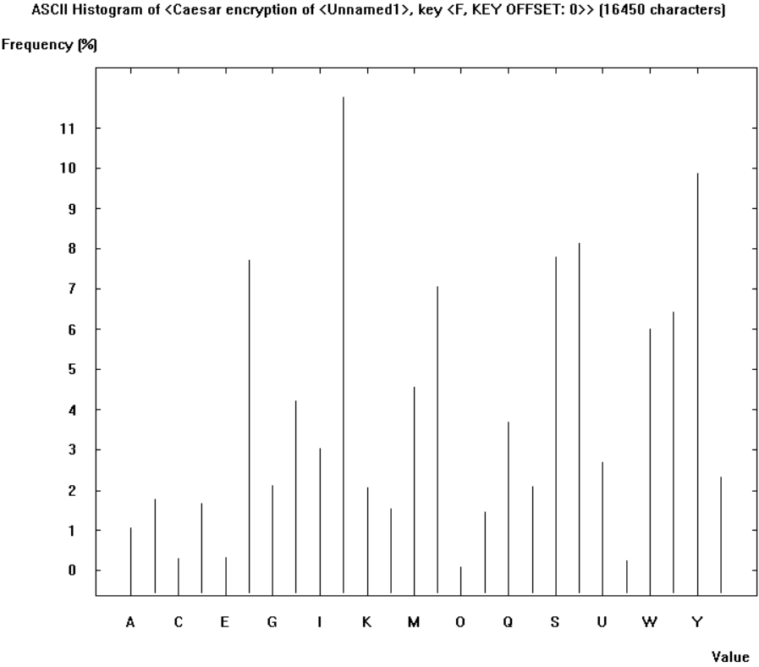
- Vigenère: 1024 length key: Mixed frequencies as the key is very large.
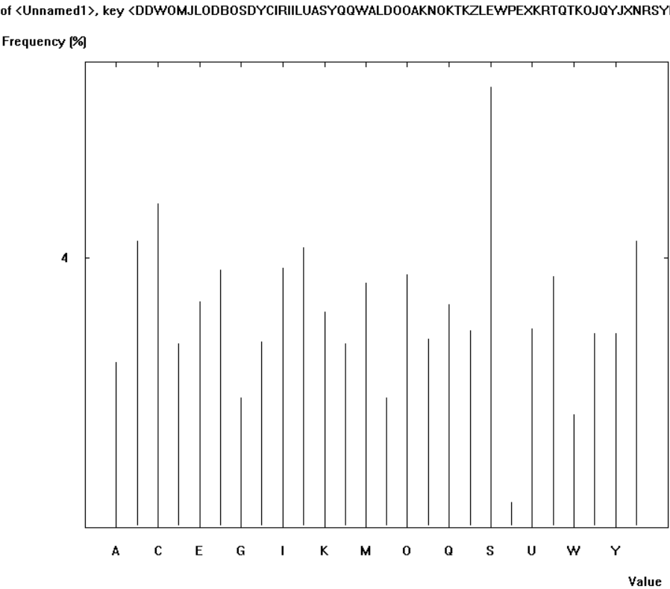
- Hill: 10x10 Also mixed frequencies as it is a 10x10 matrix.
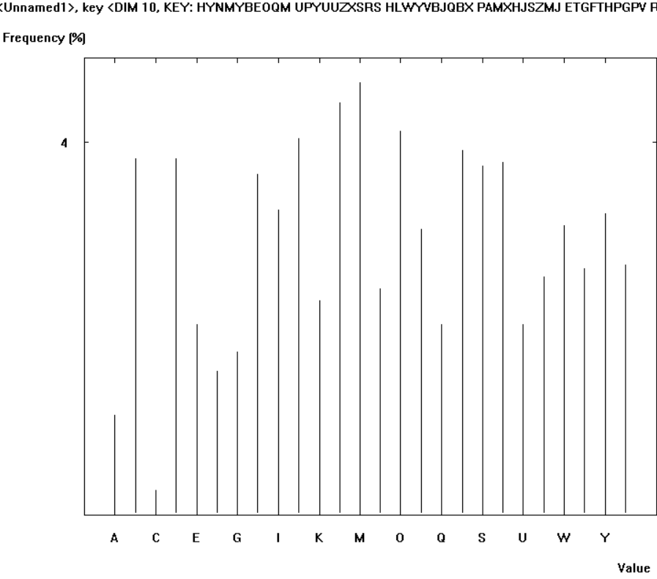
- Substitution / Atbash: We can perfectly identify that E is now J (The frequencies are unchanged).
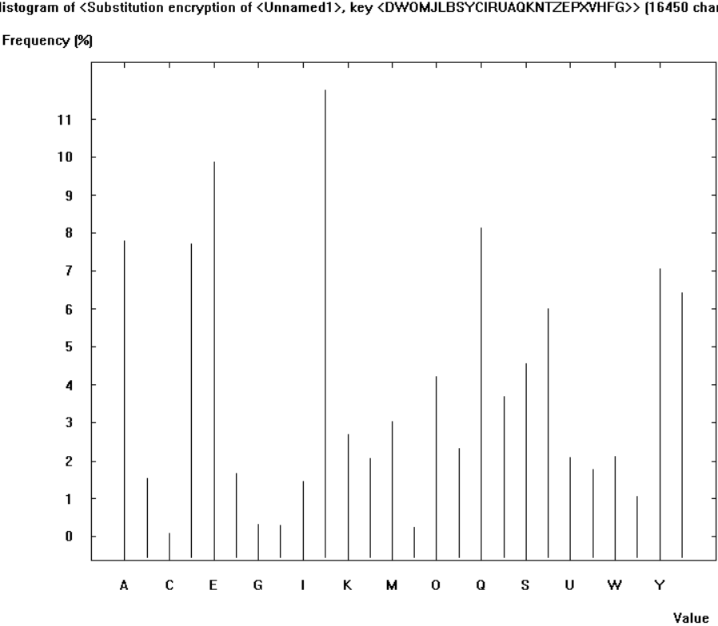
- Playfair: 6x6 We can see that is Playfair because the letter J (the default one) has 0 occurrences.
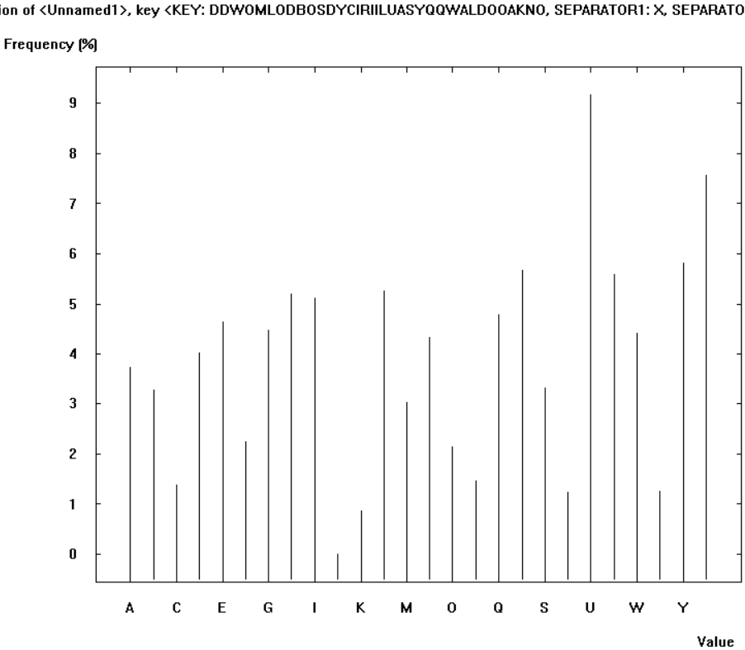
- ADFGVX: We can only identify 6 letters as expected (There are only 6 possible characters in this cypher).
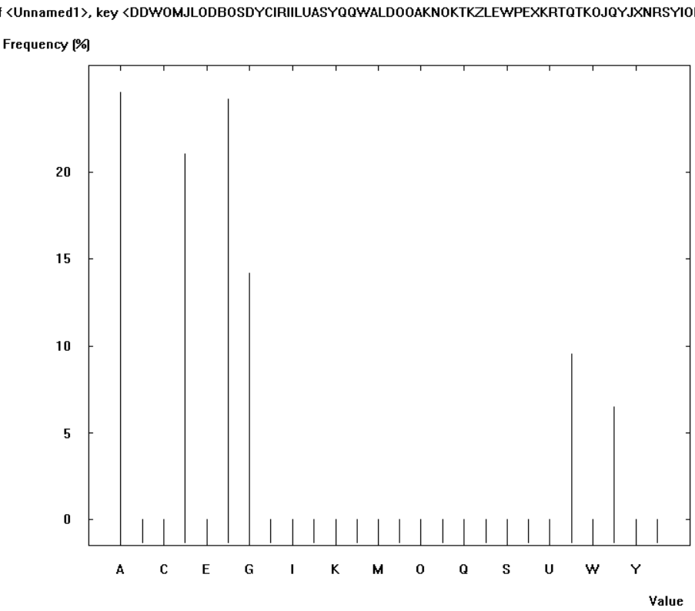
- Byte-Addition/XOR: Not useful as we work with bytes.
- Vernam / OTP: Randomness.
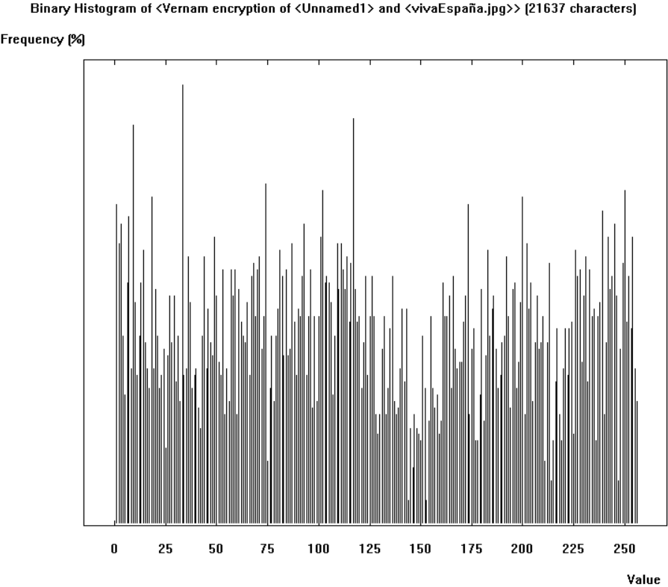
- Homophone: Cryptool crashes. It should be all nearly the same percentage all the values as the objective of this cypher is to normalize frequencies.
- Permutation / Transposition: We still can see patterns (frequencies), but the text is scrambled.
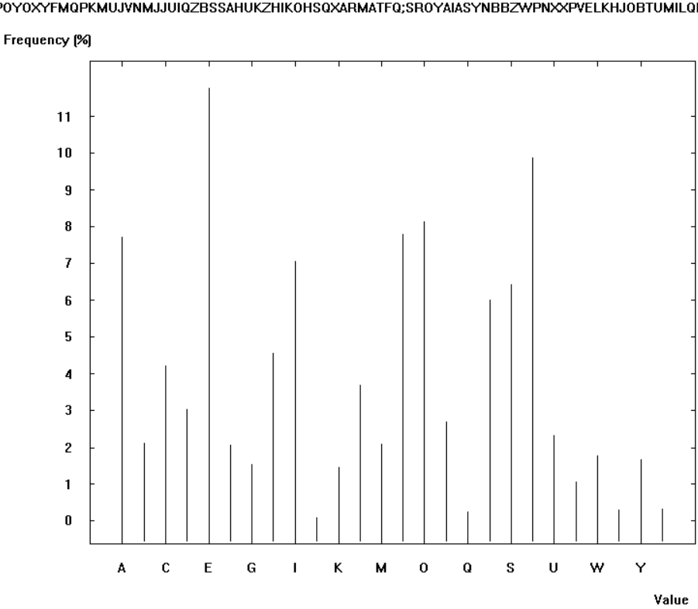
- Solitaire: Random unpredictable pattern
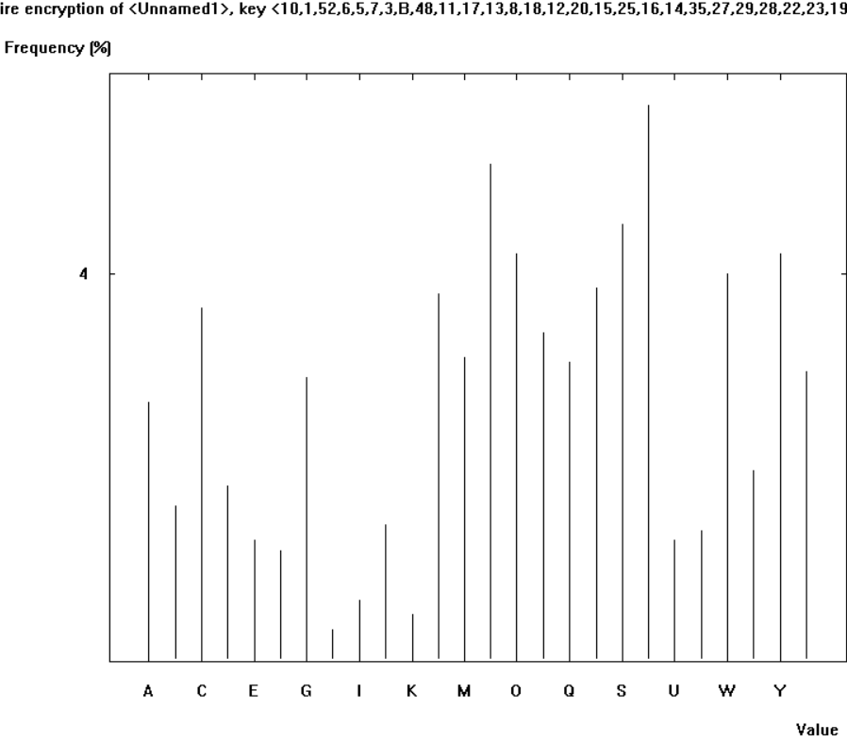
- Scytale / Rail-Fence: The text is the same so same histogram
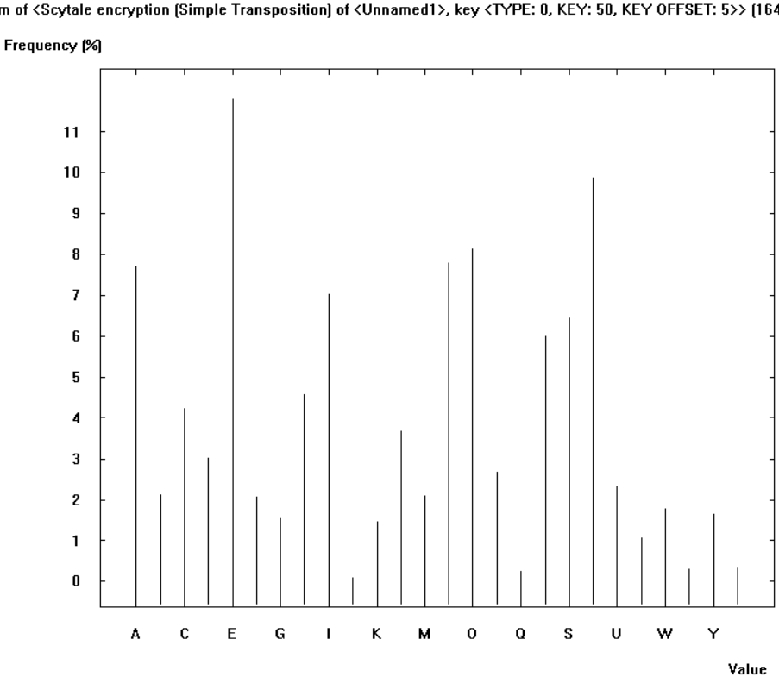

Compare n-grams (bi/tri/n) of plaintexts for selected 3 different languages (English, Polish, German, French, Italian, Spanish, ...):
English:
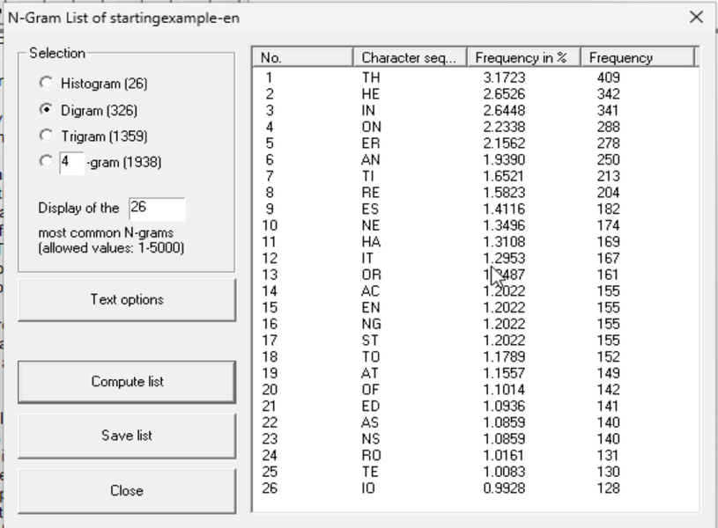
- Digram:
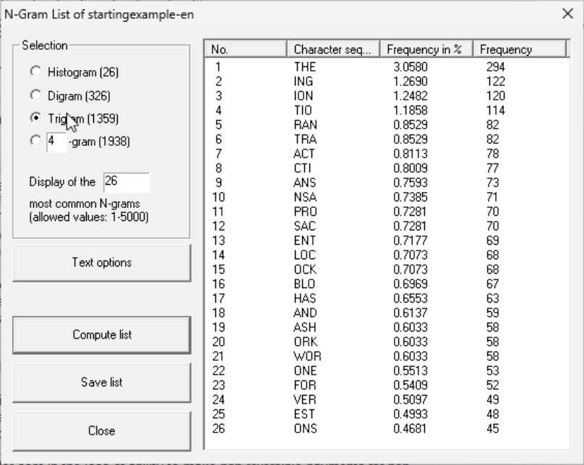
- Trigram:

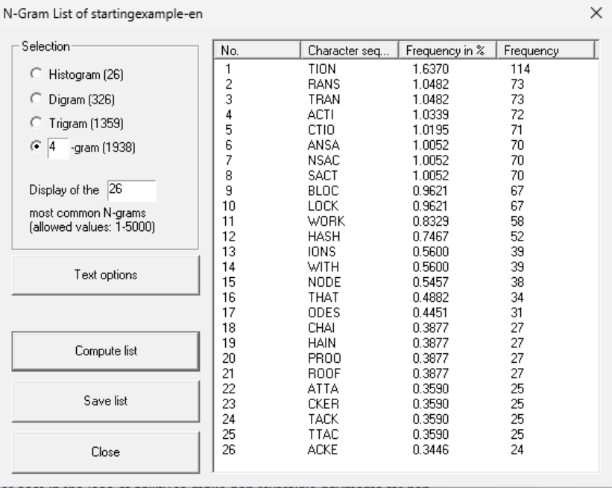
- 4-gram:

Spanish:
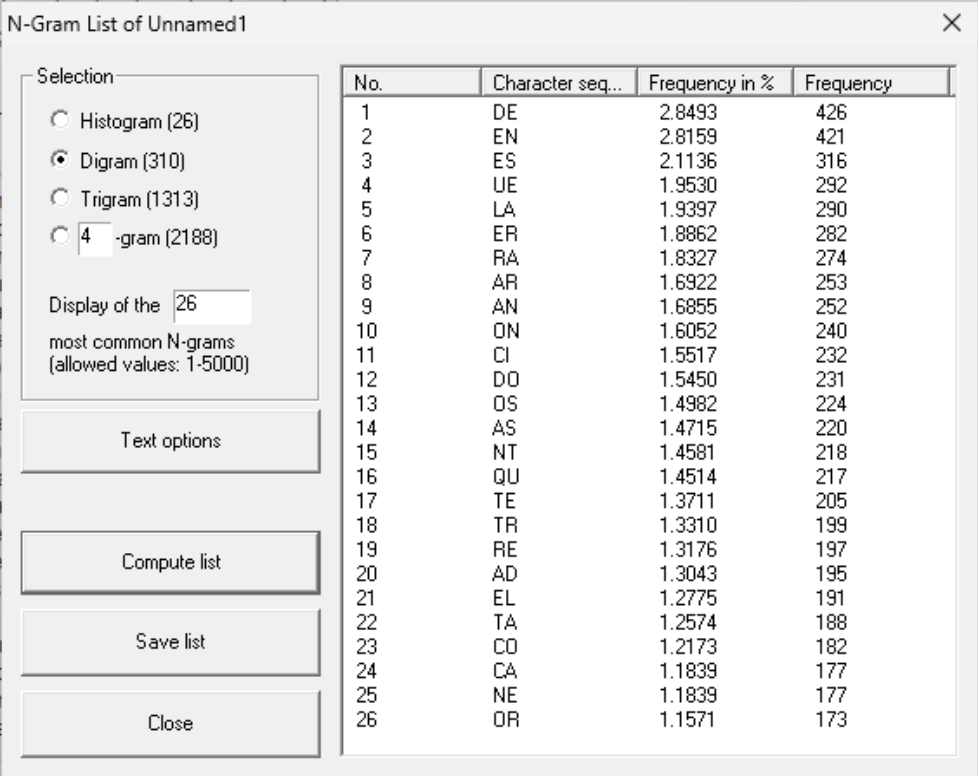
- Digram:

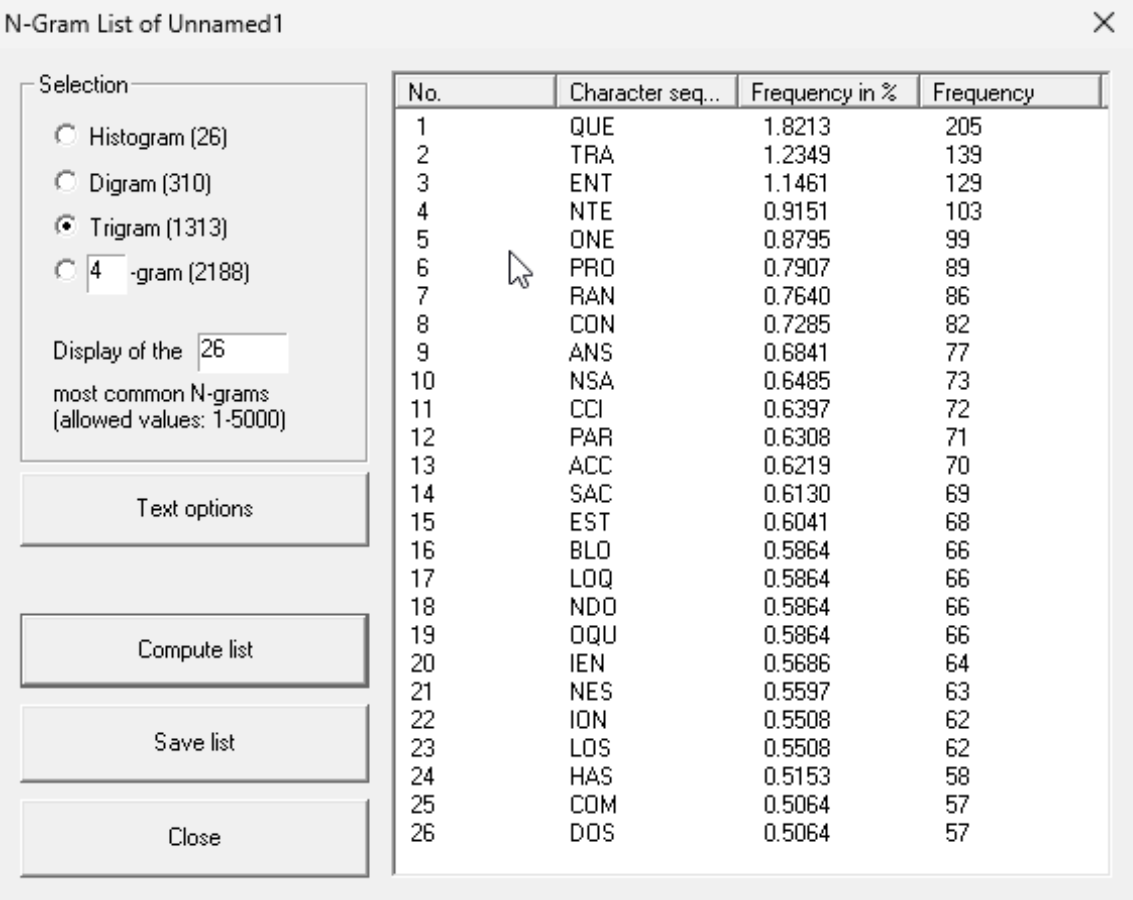
- Trigram:

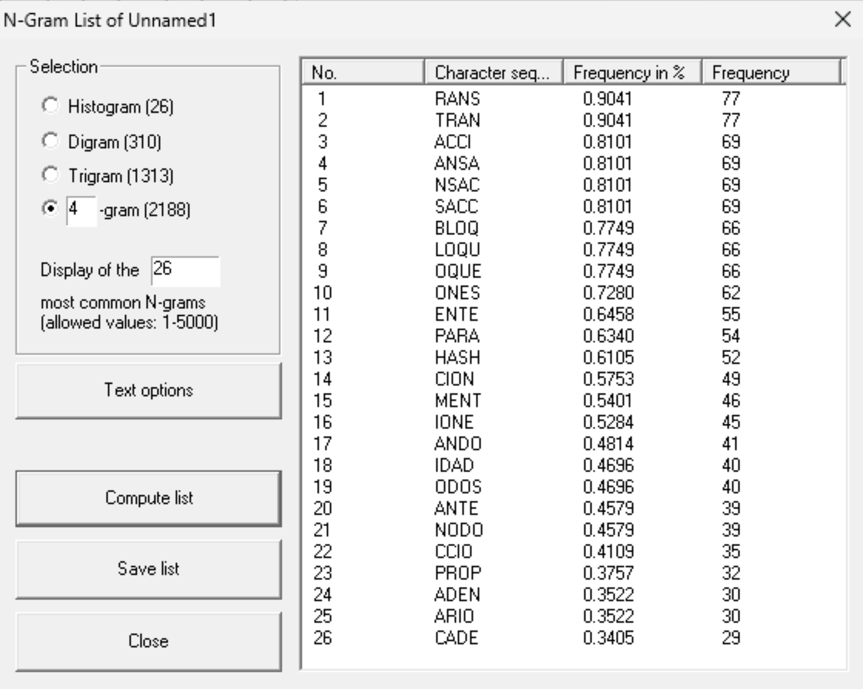
- 4-gram:

Polish:
- Digram:
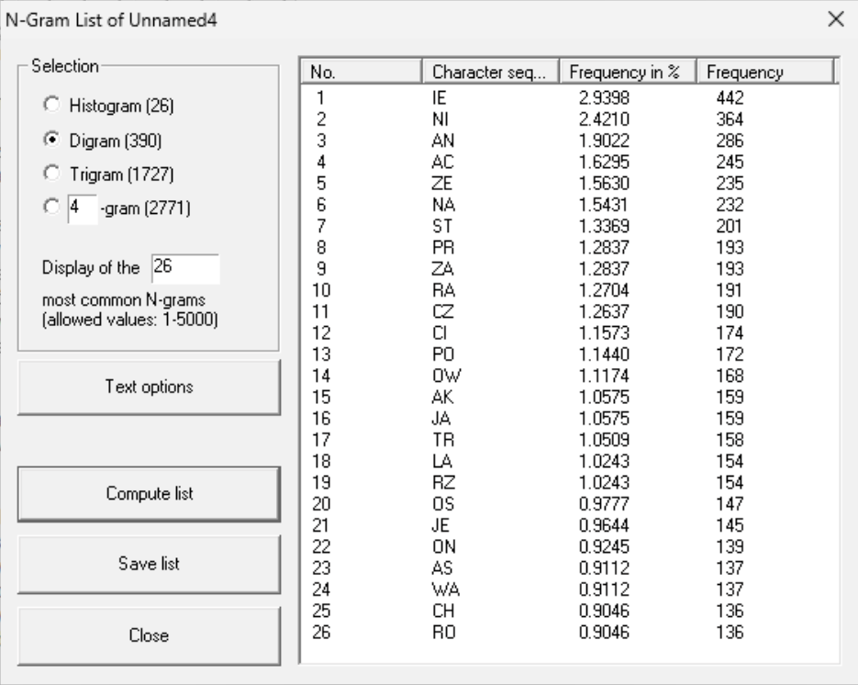

- Trigram:
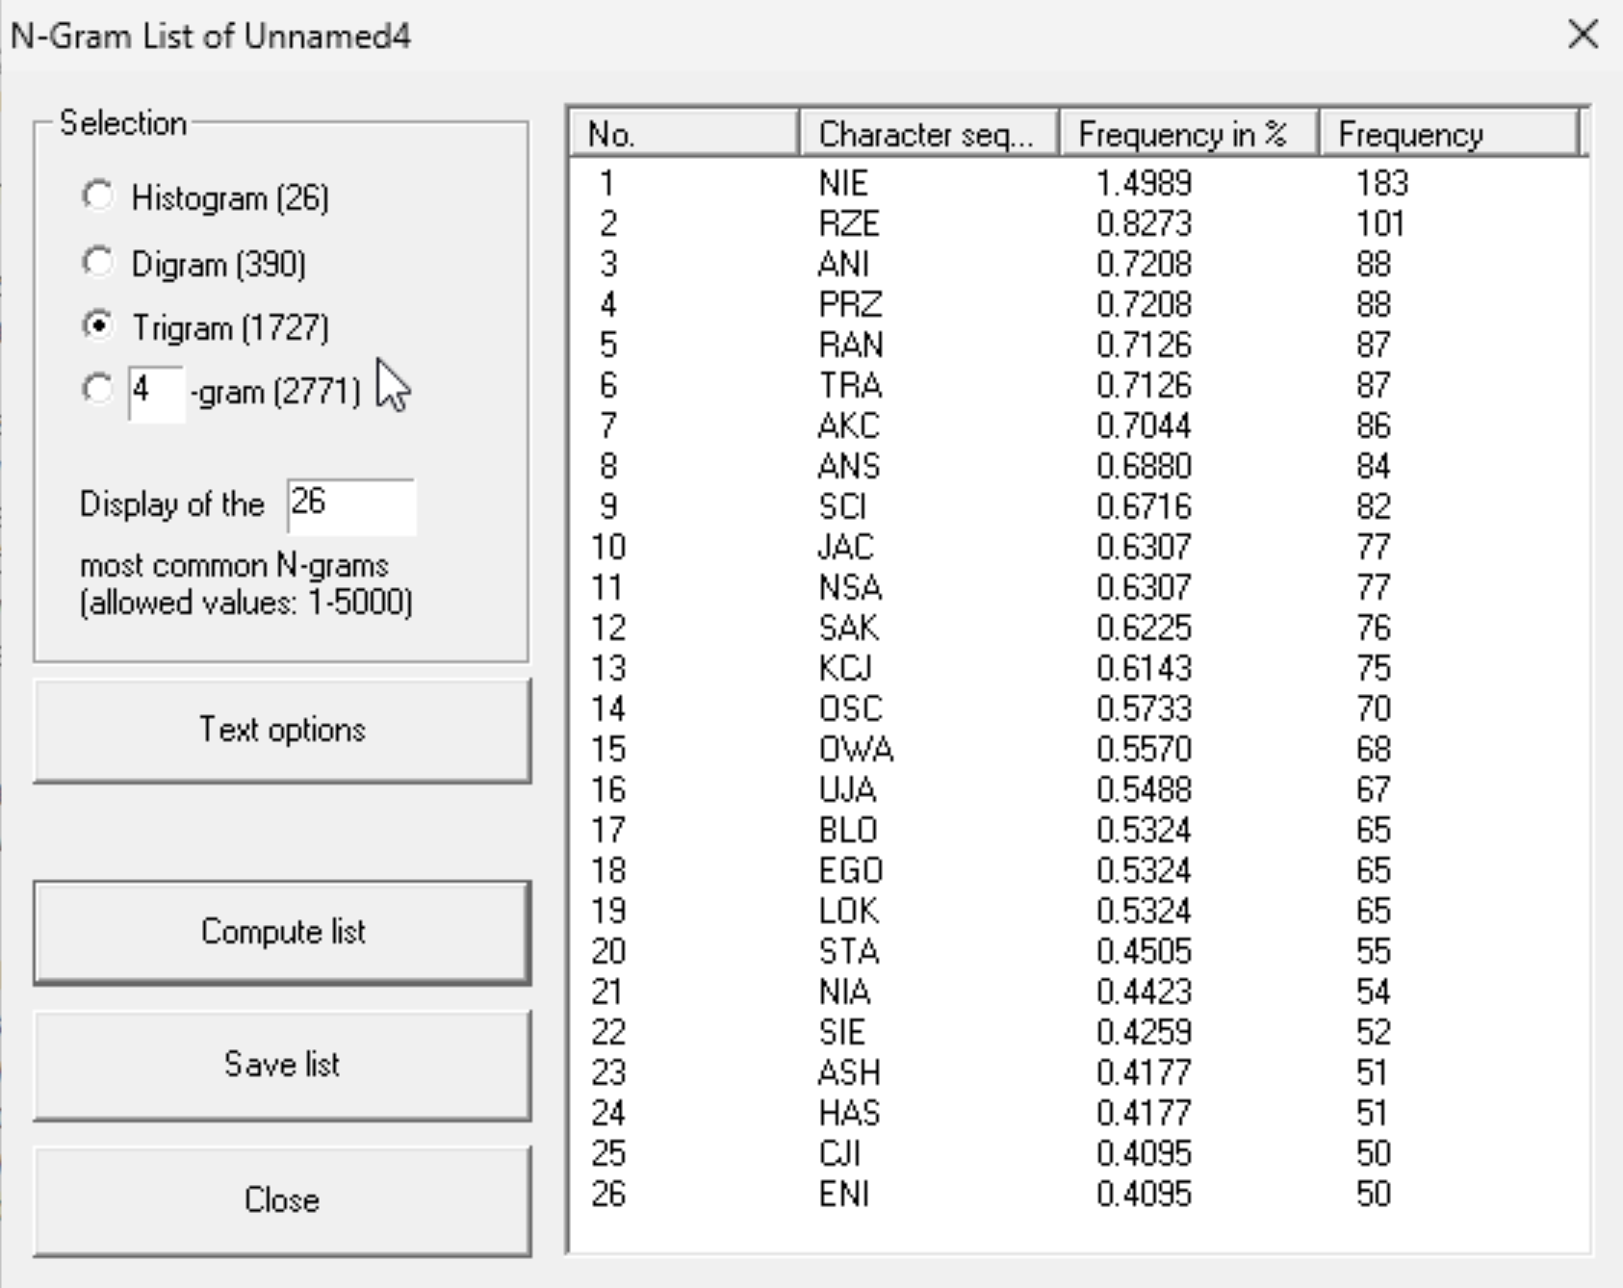

- 4-gram:
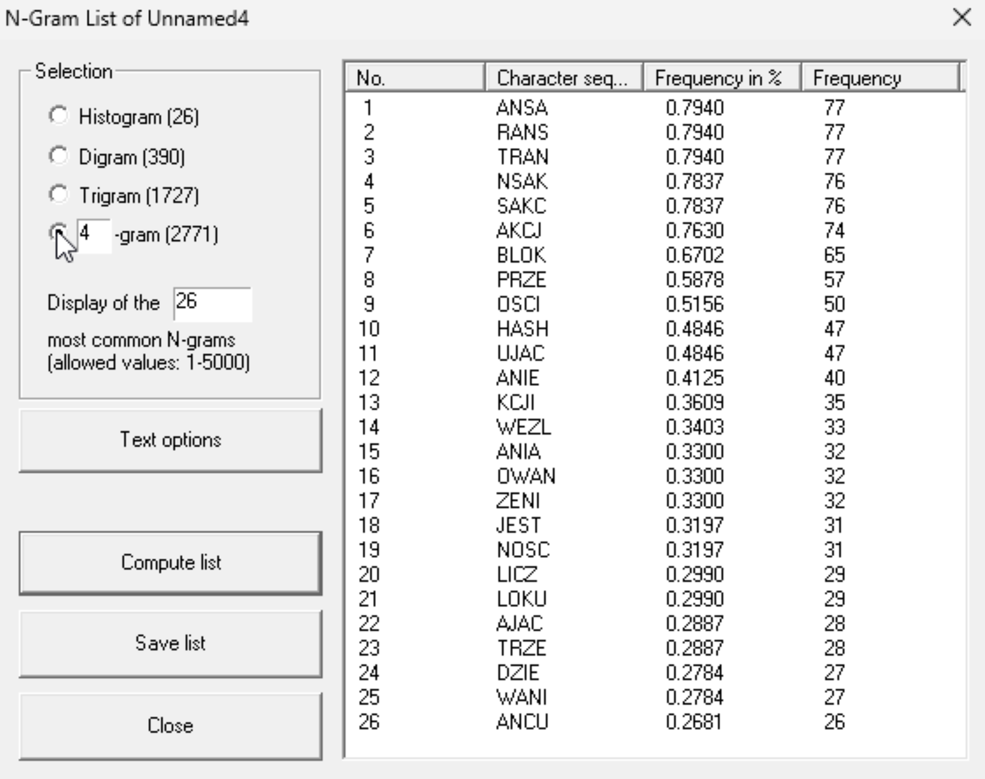
With the n-gram analysis se can get secarral conclusiones. English n-grams show frequent articles and endings as TH, HE, IN, THE,… . Spanish show several combinations as DE, EN, ES, and QUE that shows that Spanish uses a lot of vowels. Finally, Polish reflects the complex of the language, as we can se several combinations of consonantes.

Compare n-games (bi/tri/n) of plaintext and ciphertext depending on the algorithm. For algorithms such as in point 2:
Caesar: Key: E
- English:
- Digram:
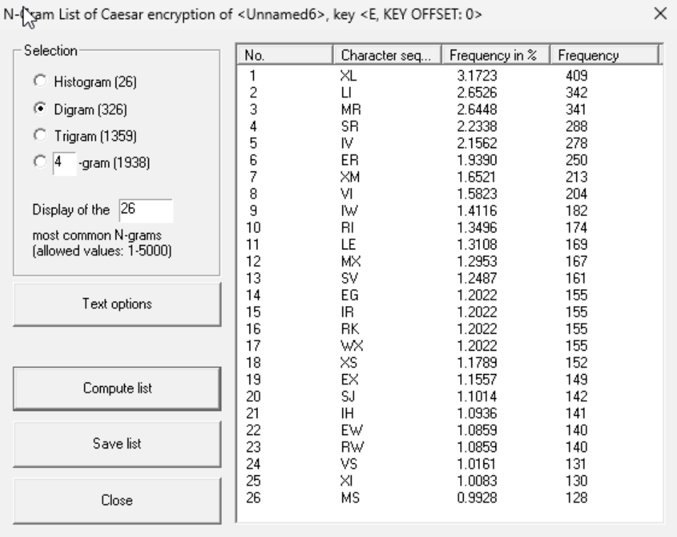
- Trigram:
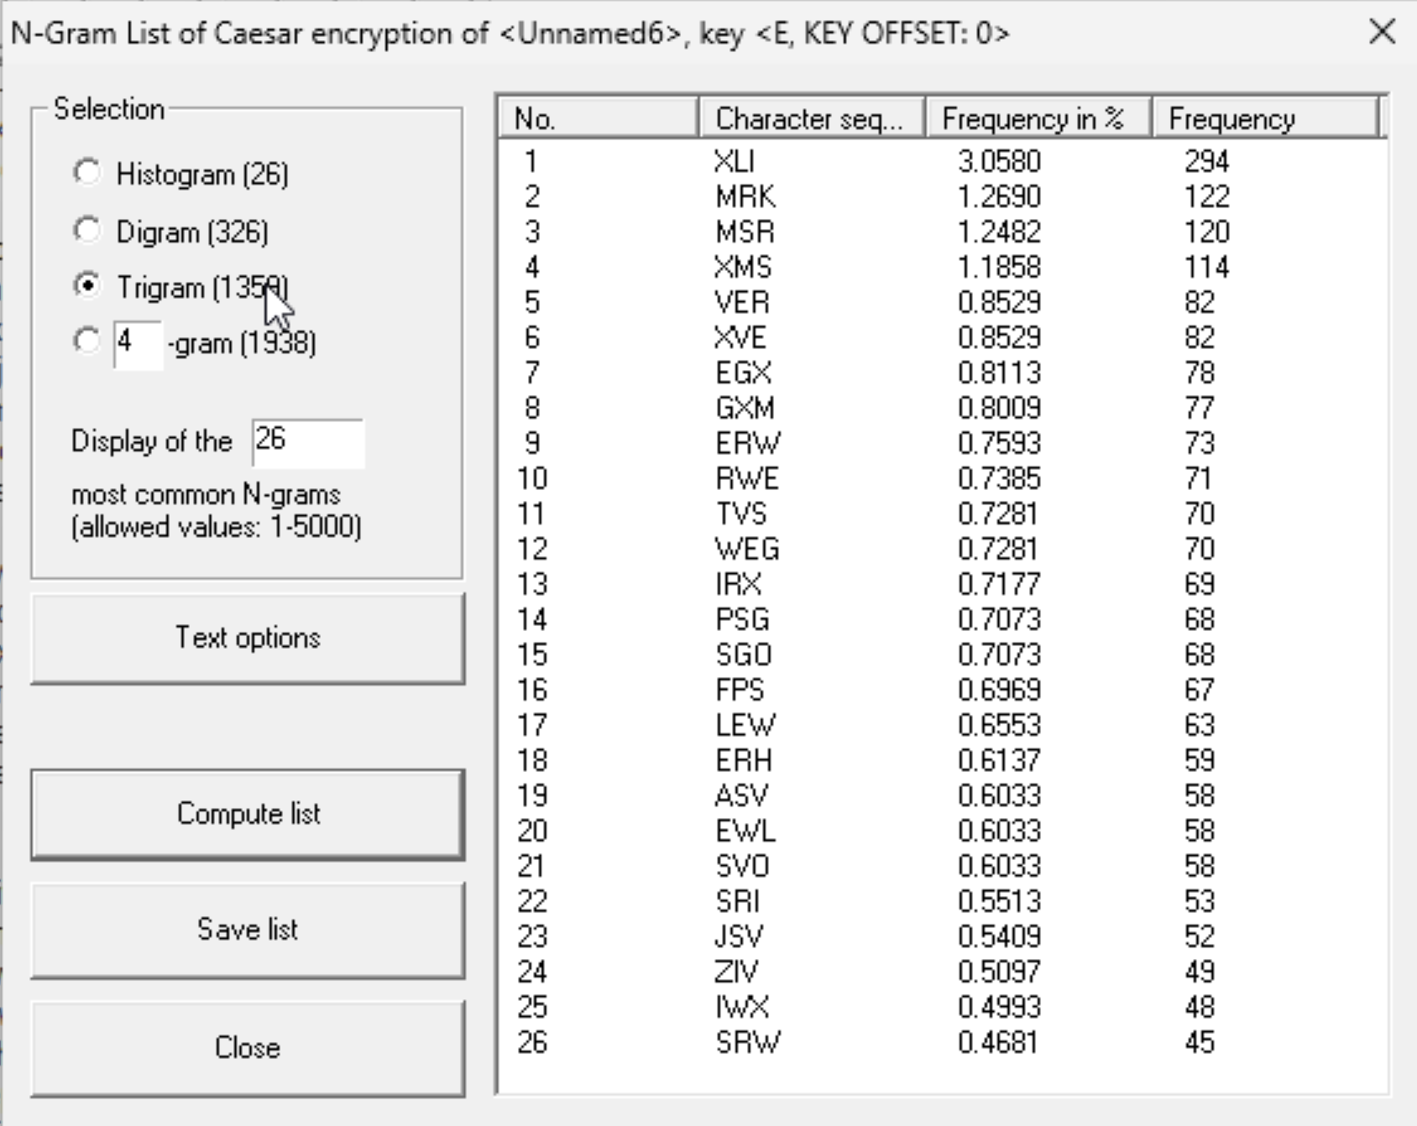

- 4-gram:
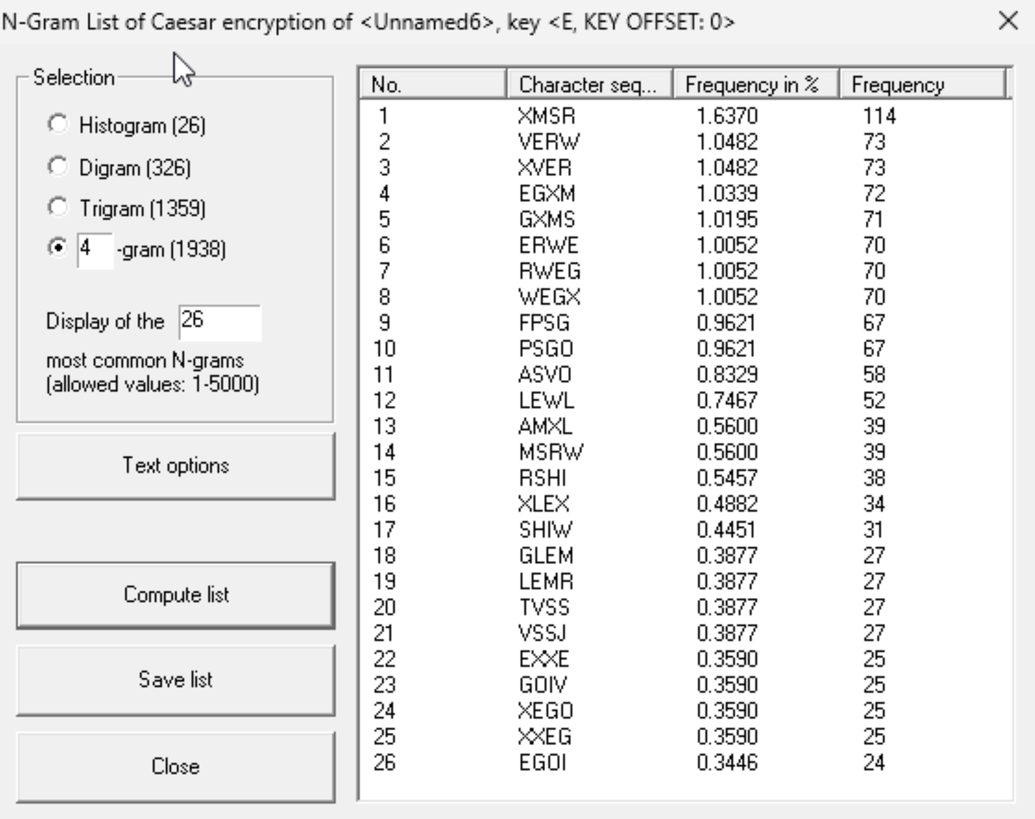

- Spanish:
- Digram:
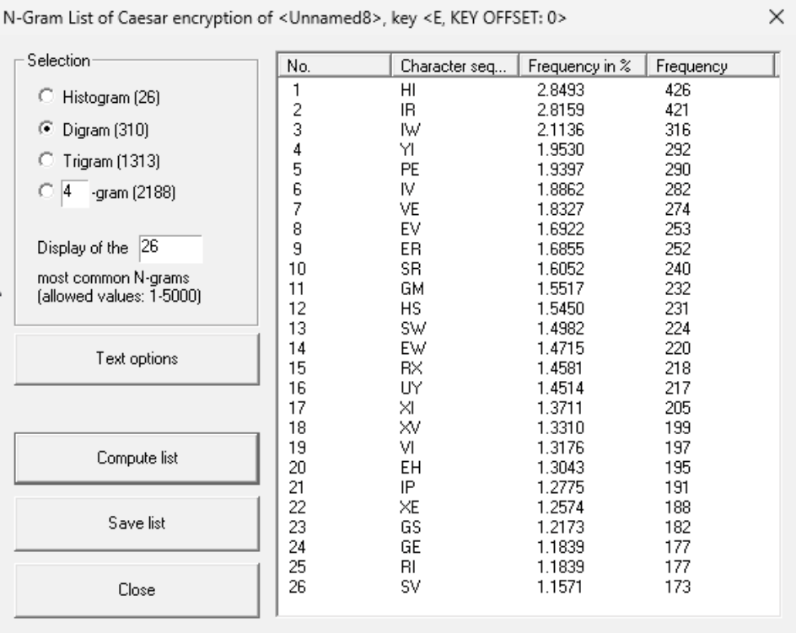

- Trigram:
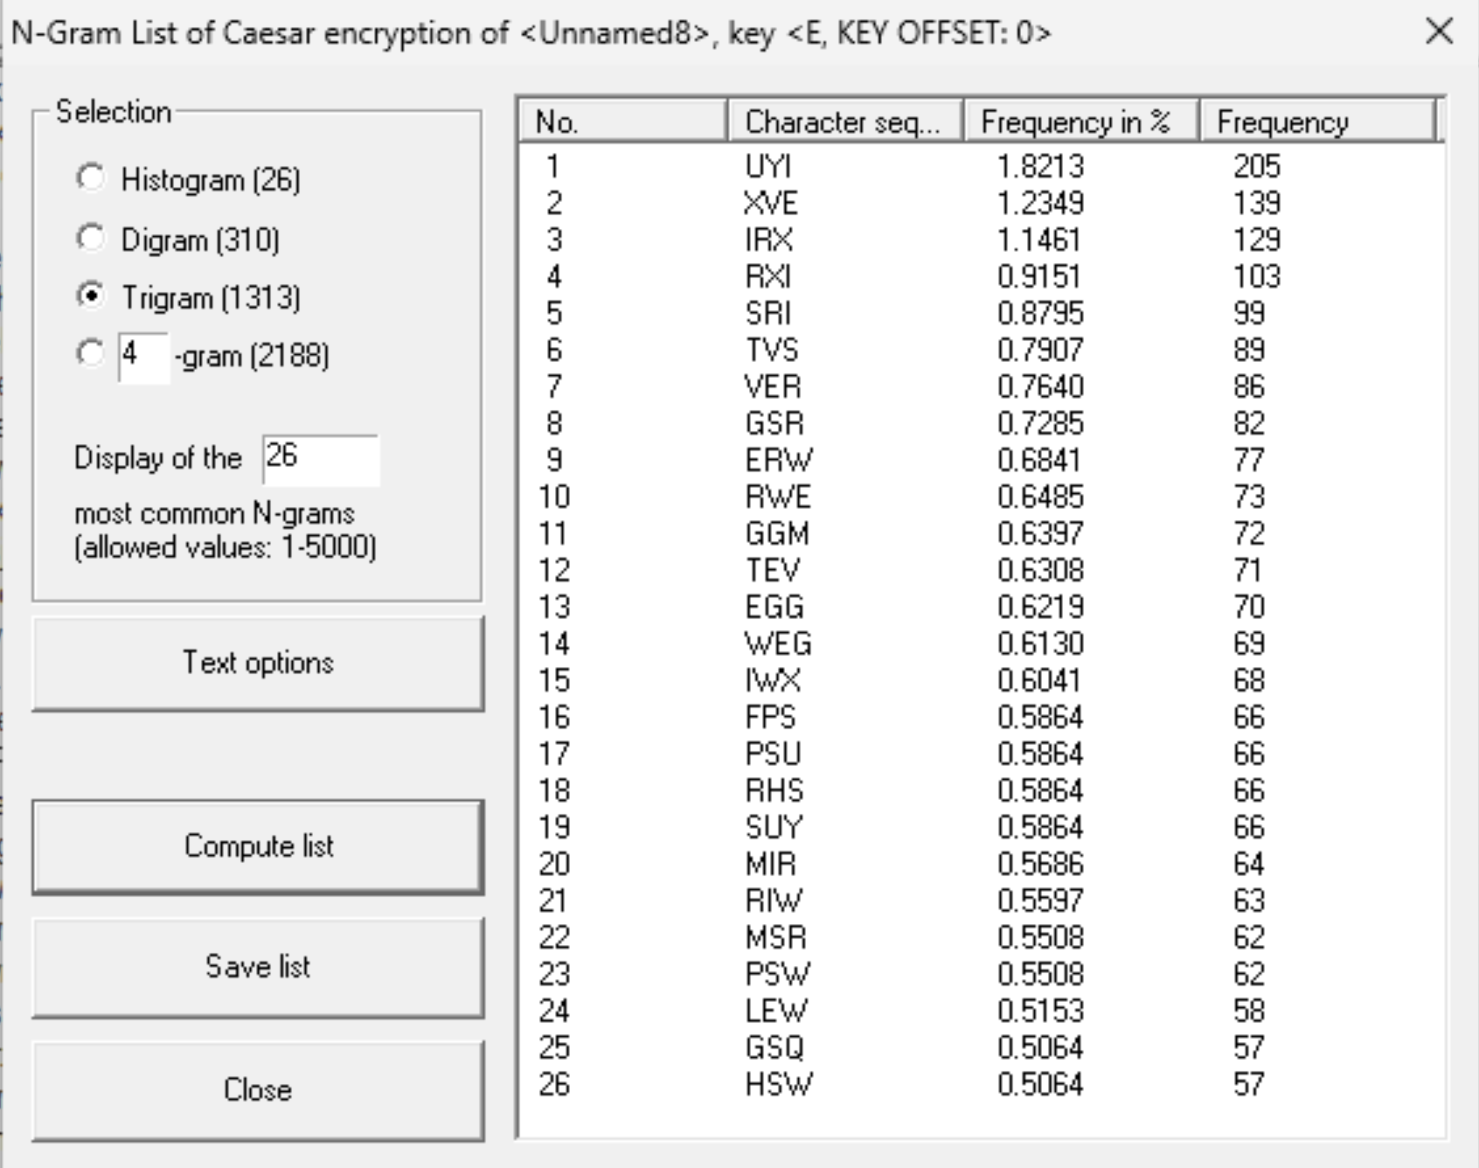

- 4-gram:
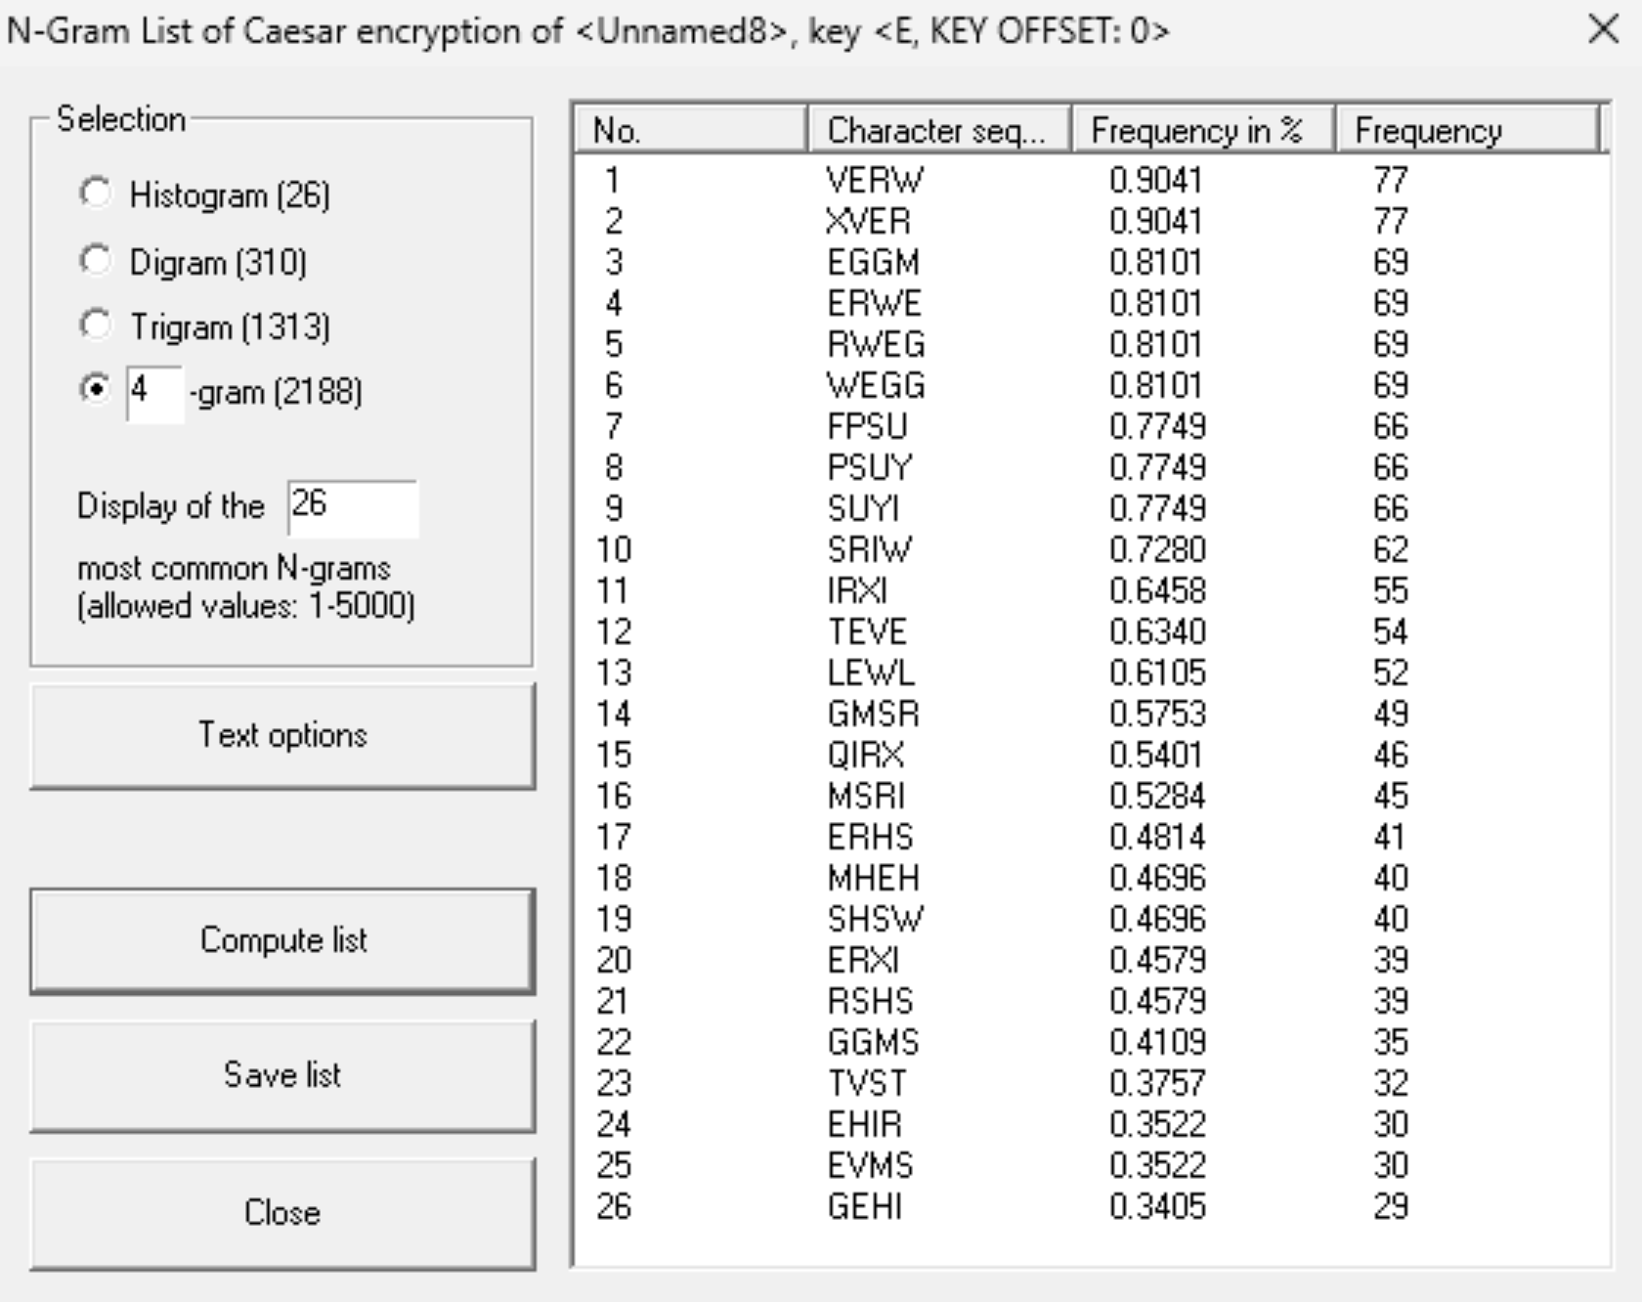

- Polish:
- Digram:
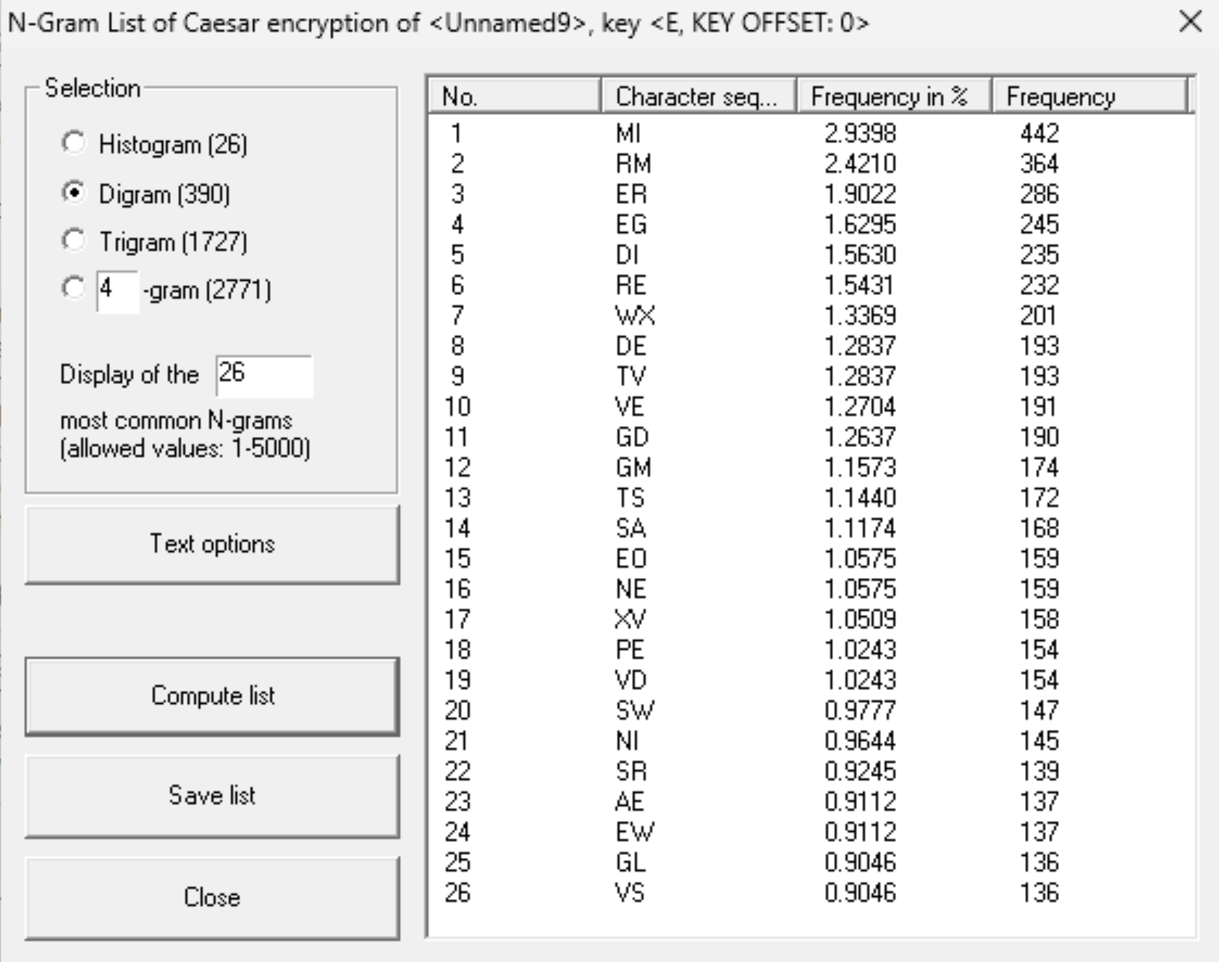

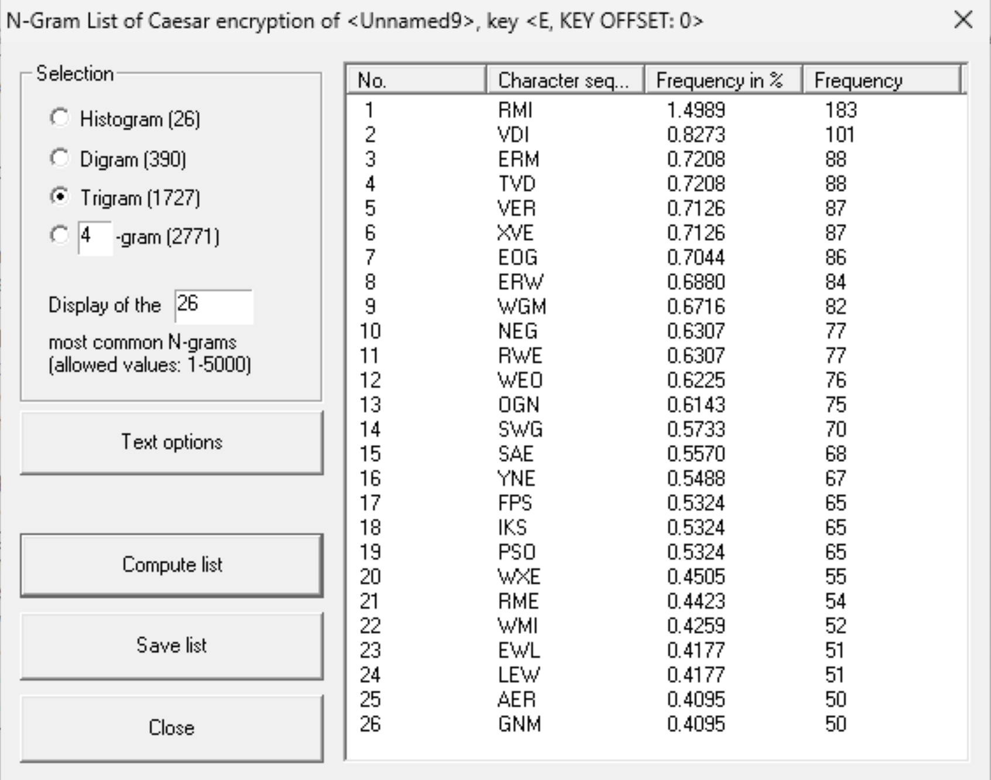
- Trigram:

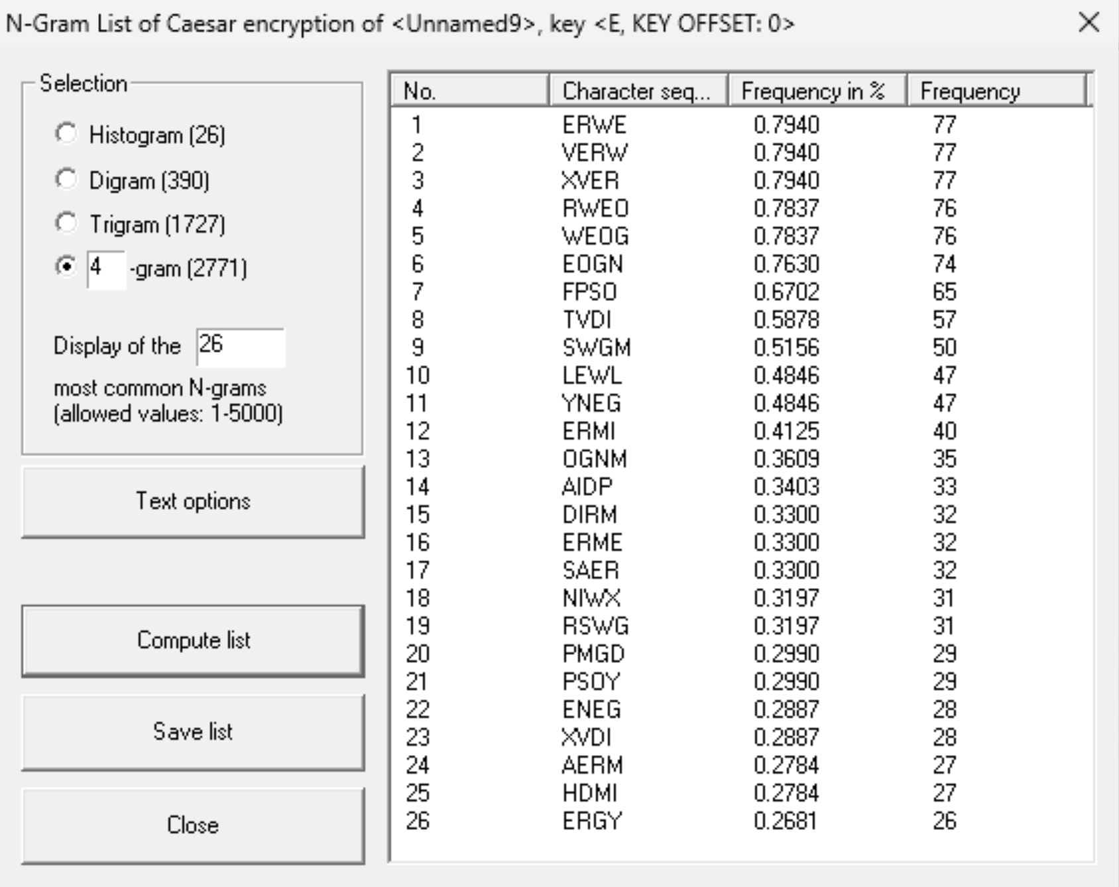
- 4-gram:

Vigenère: Key:”KEY”
- English:
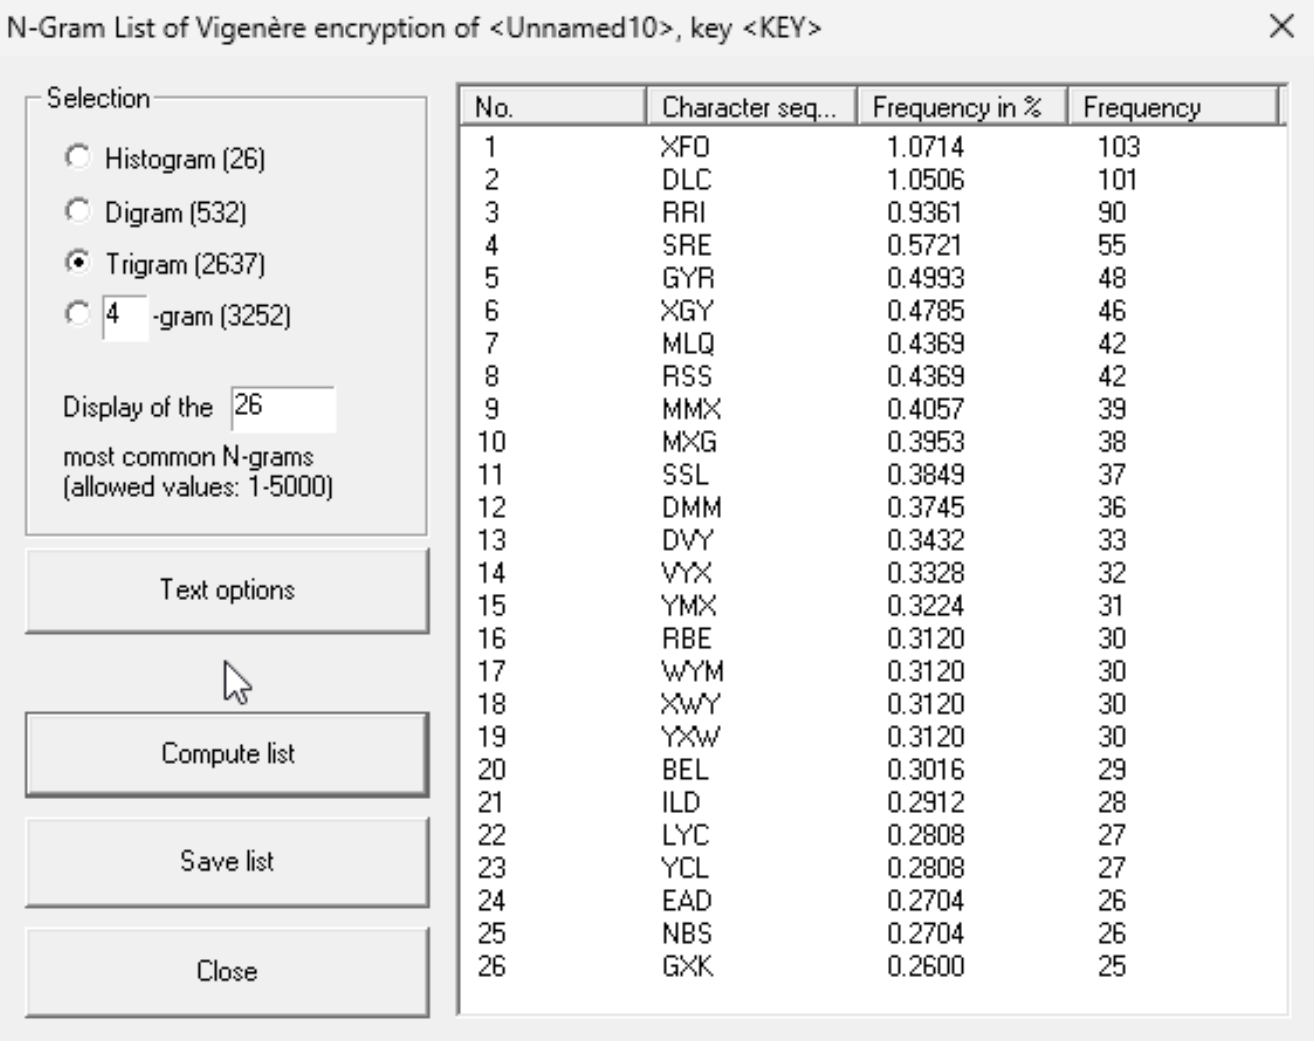
- Digram:

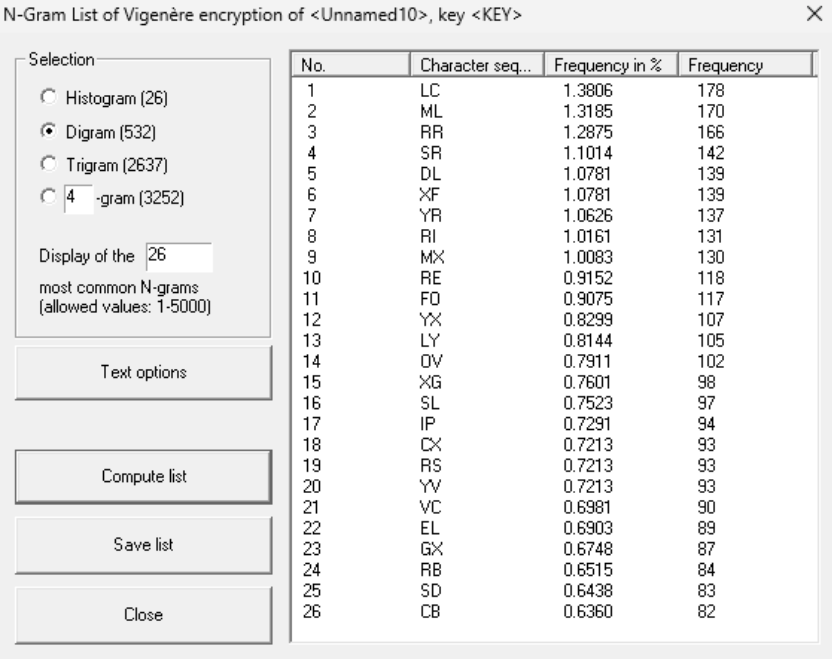
- Trigram:

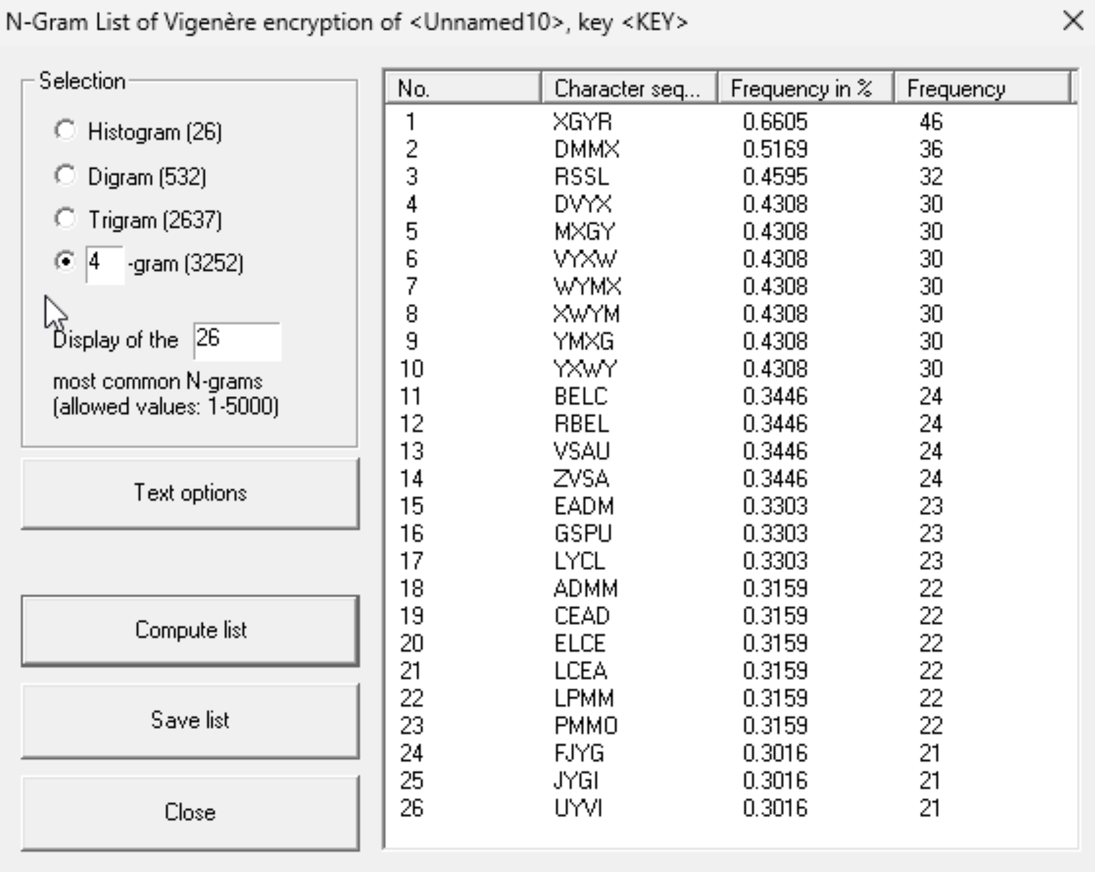
- 4-gram:

- Spanish:
- Digram:
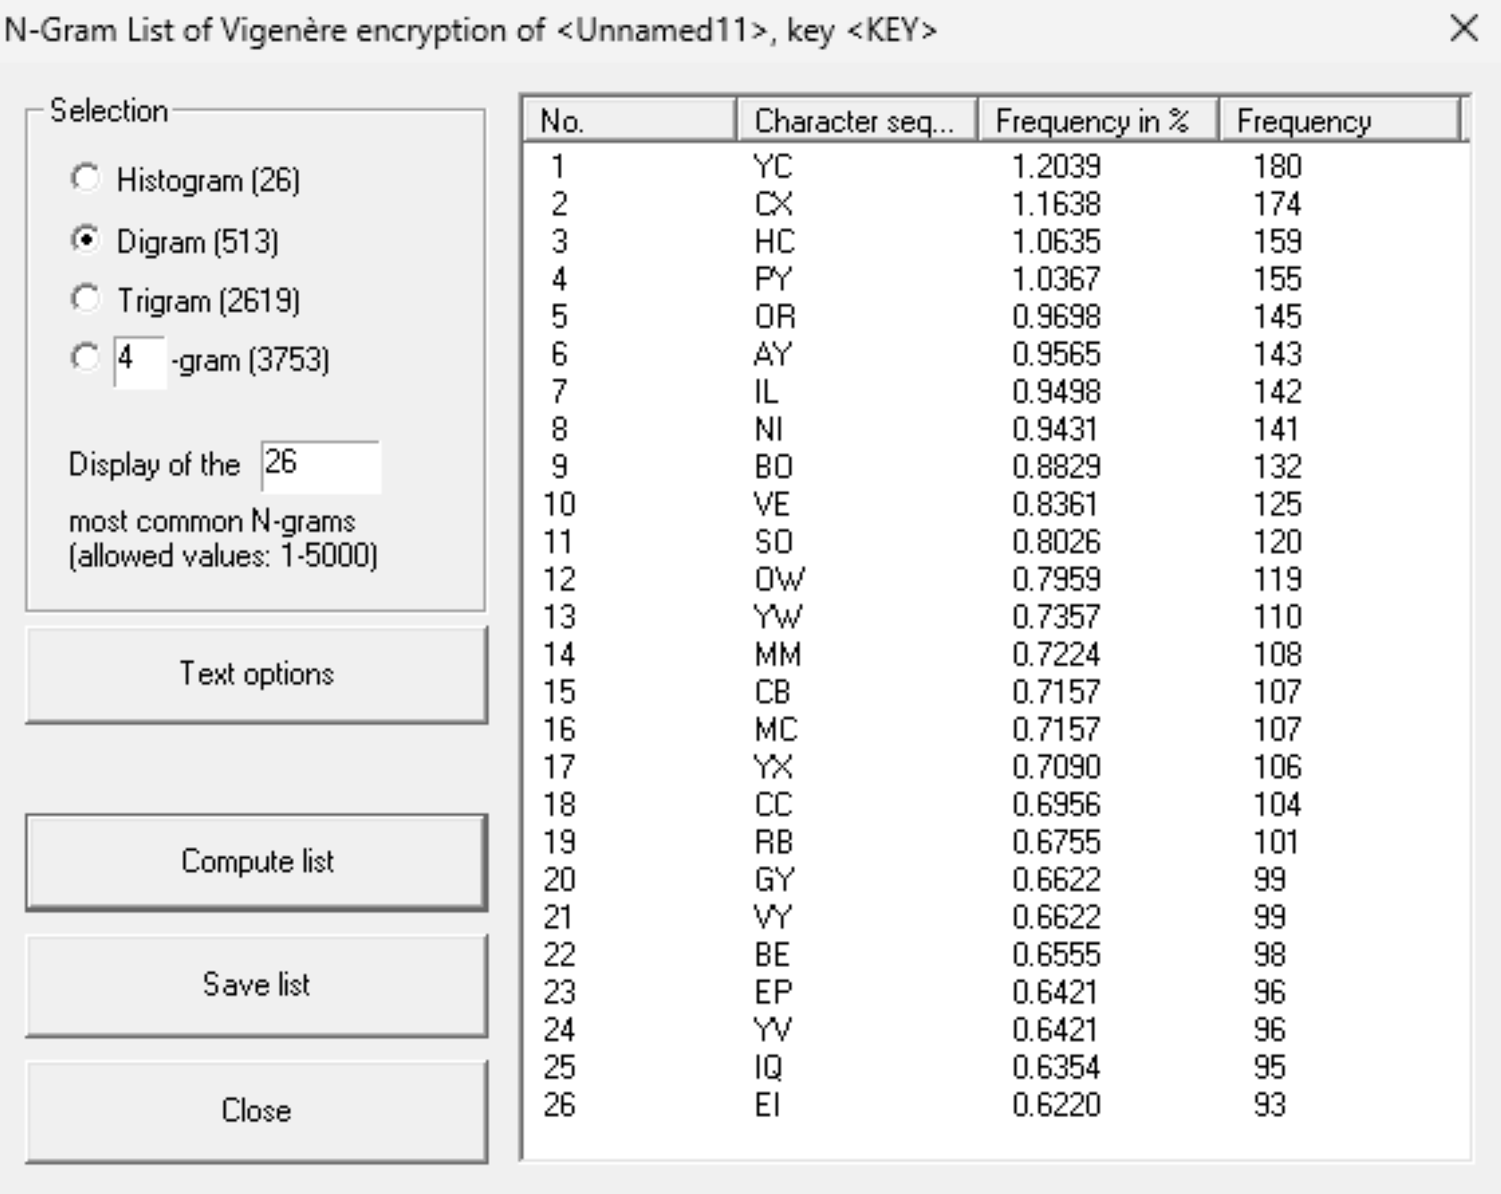

- Trigram:
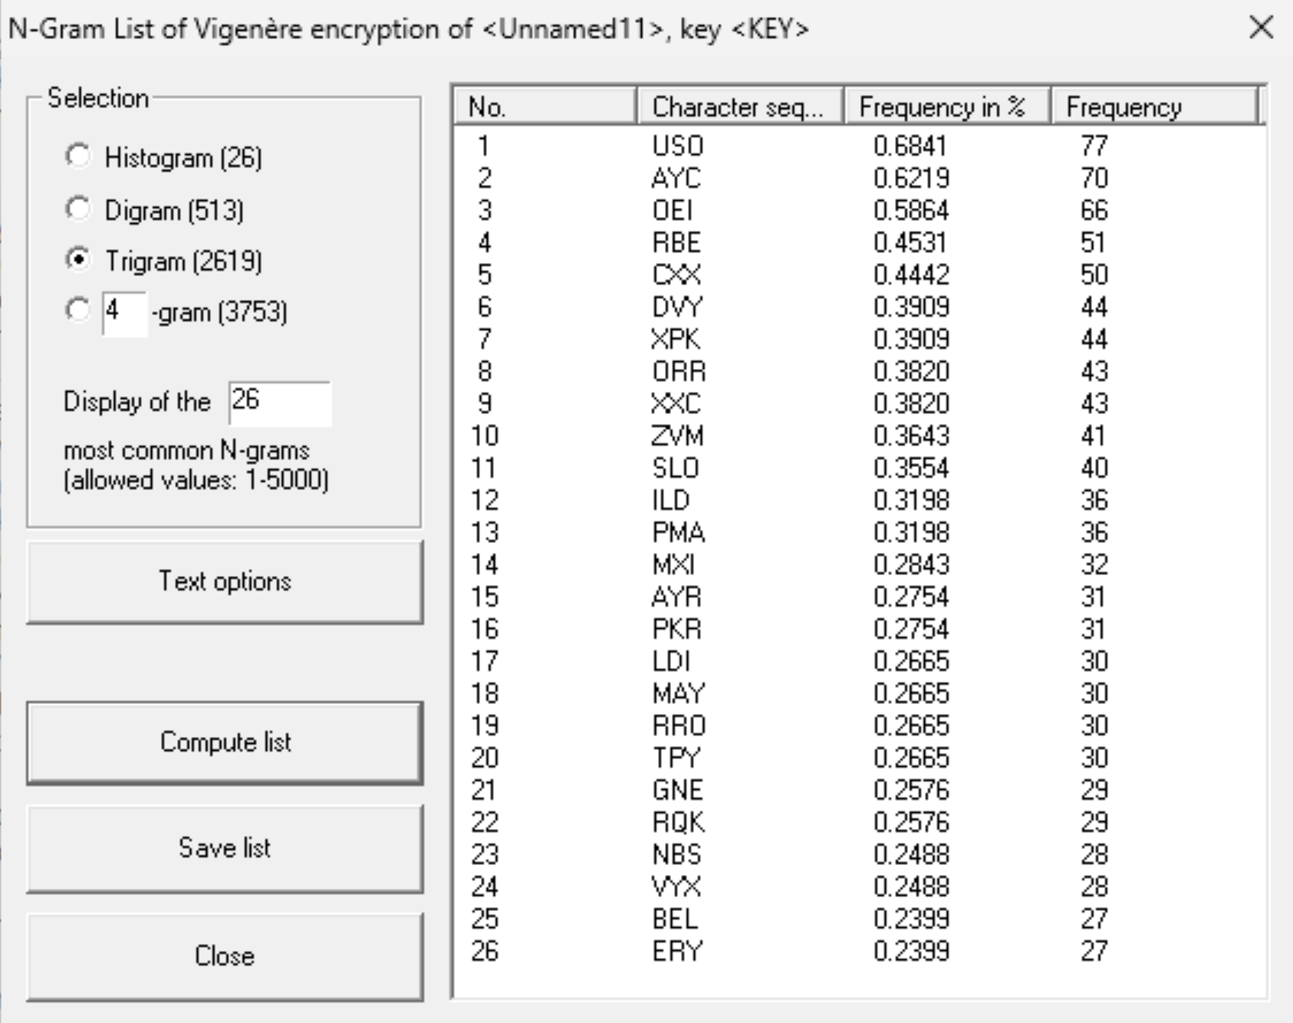

- 4-gram:
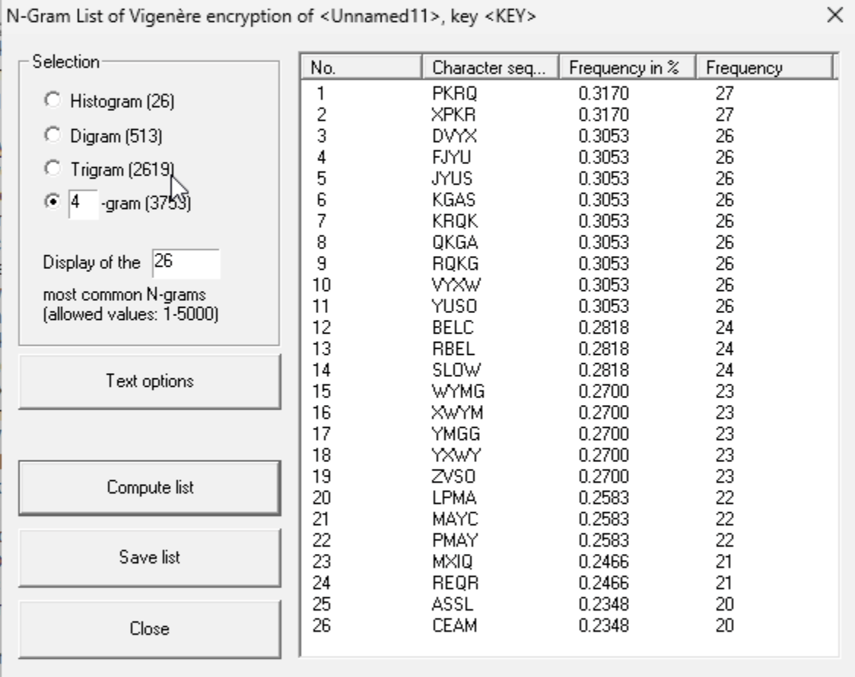

- Polish:
- Digram:
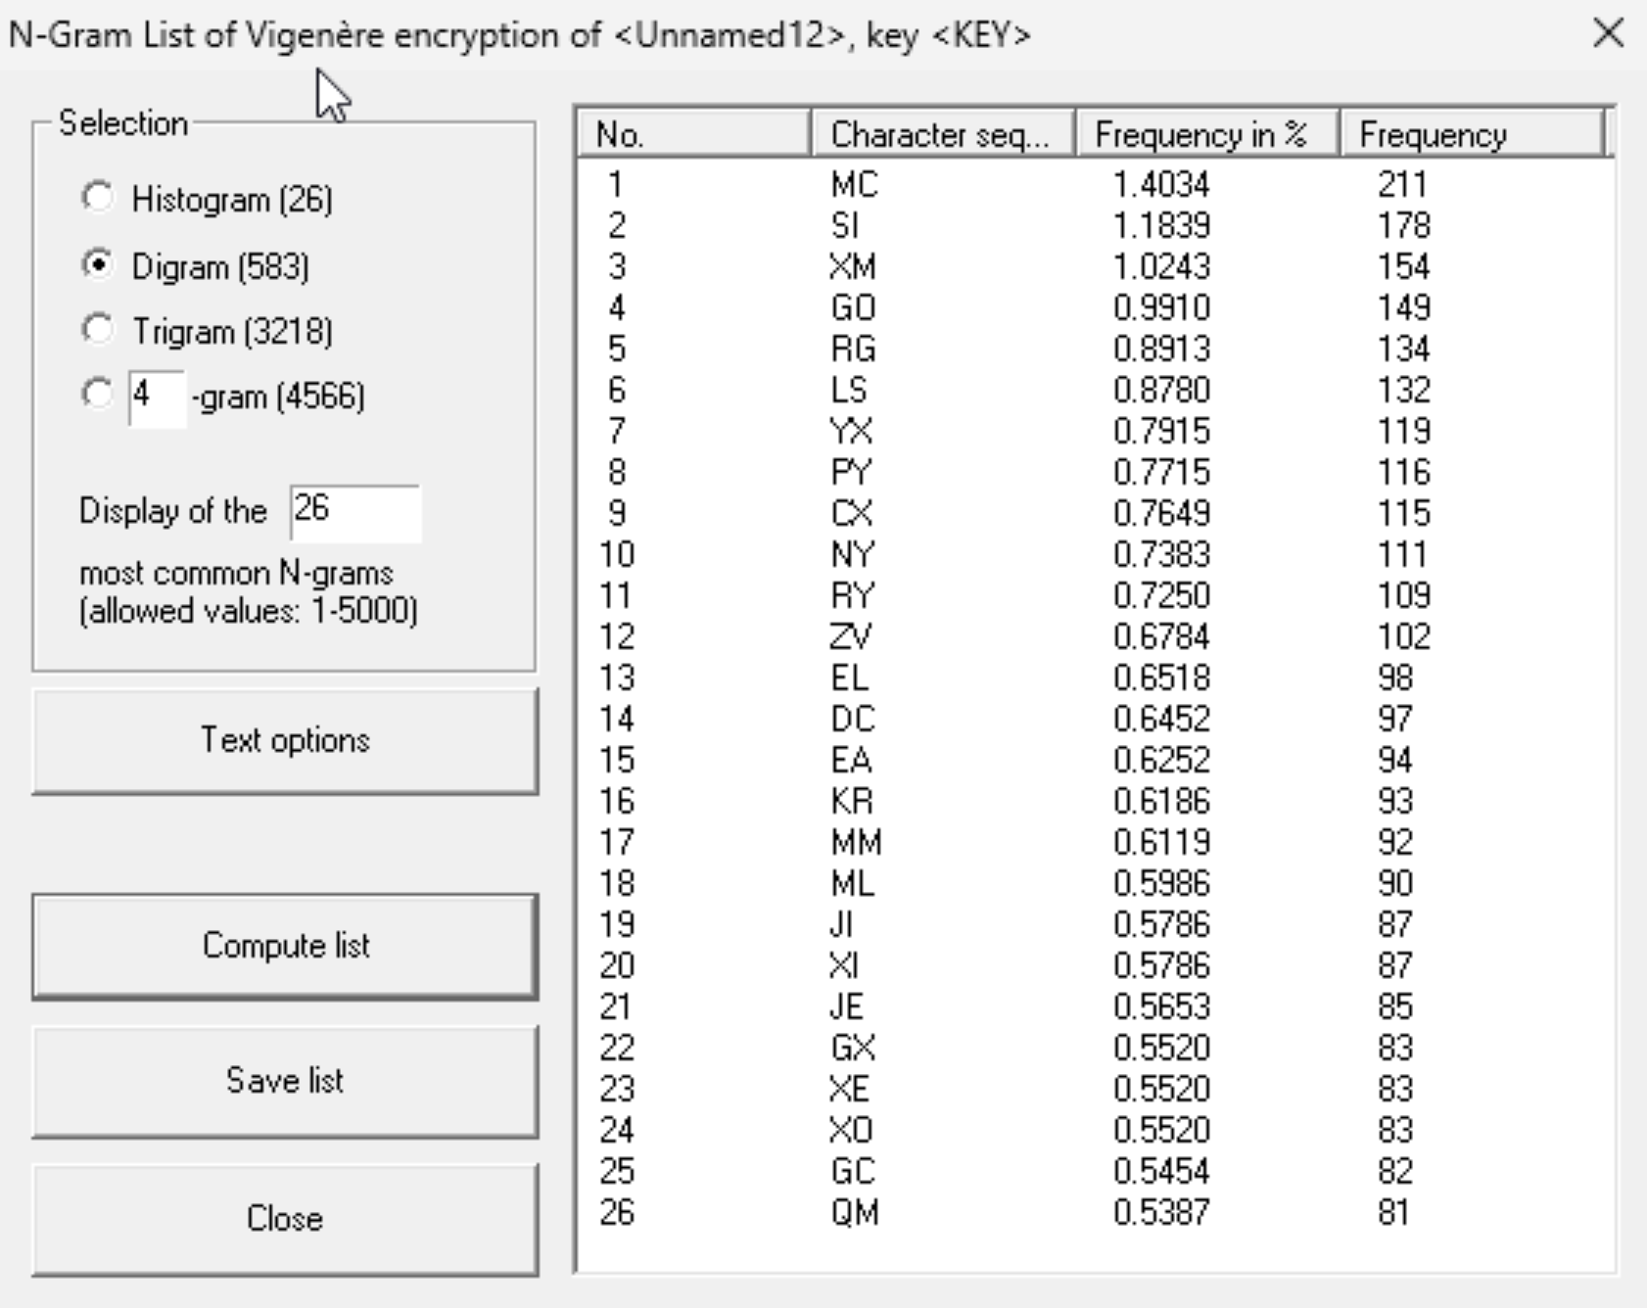

- Trigram:
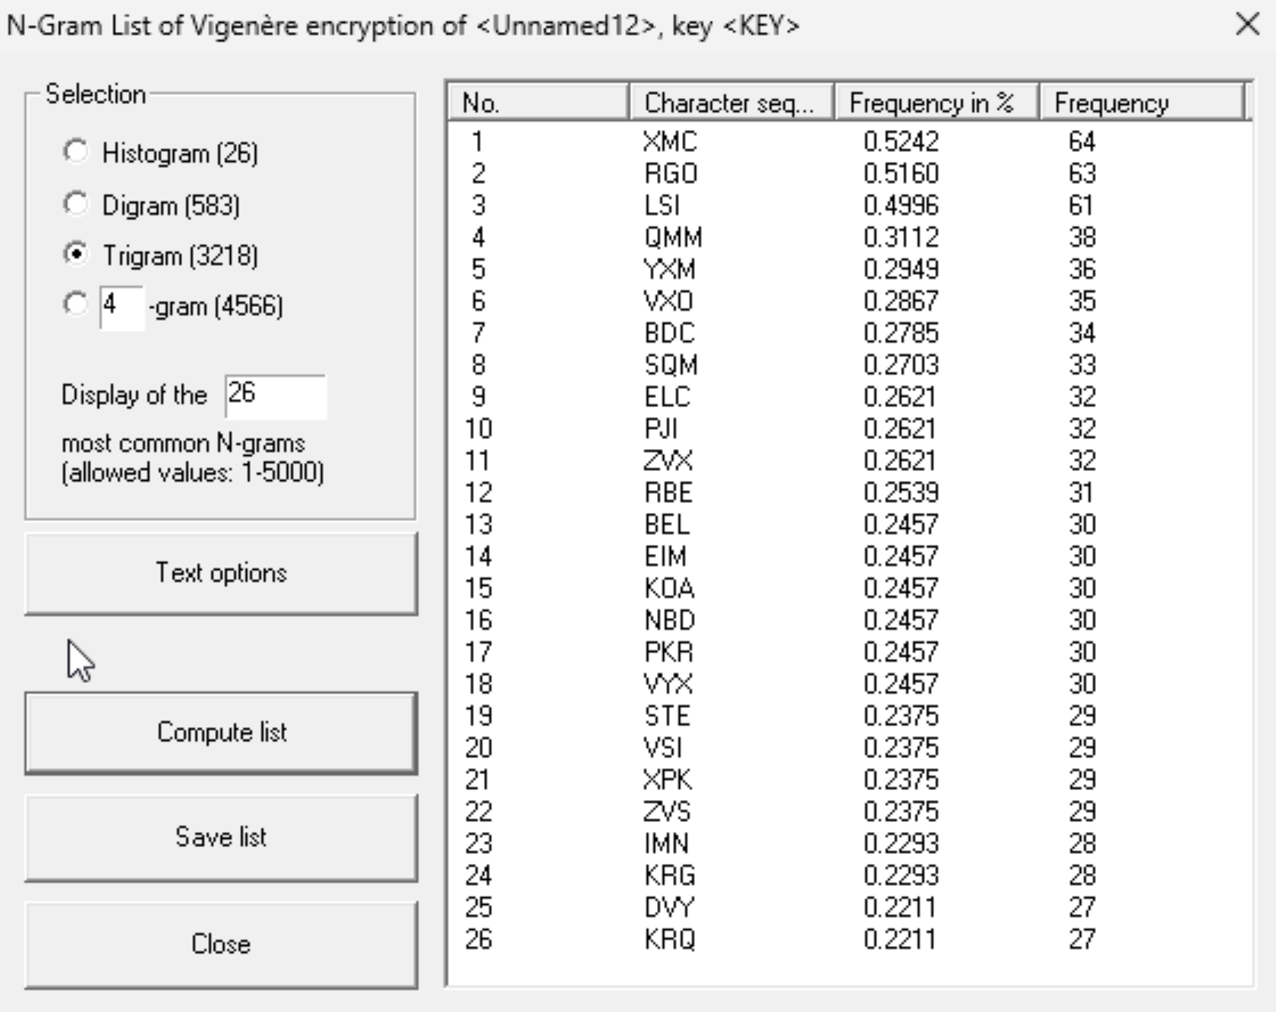

- 4-gram:
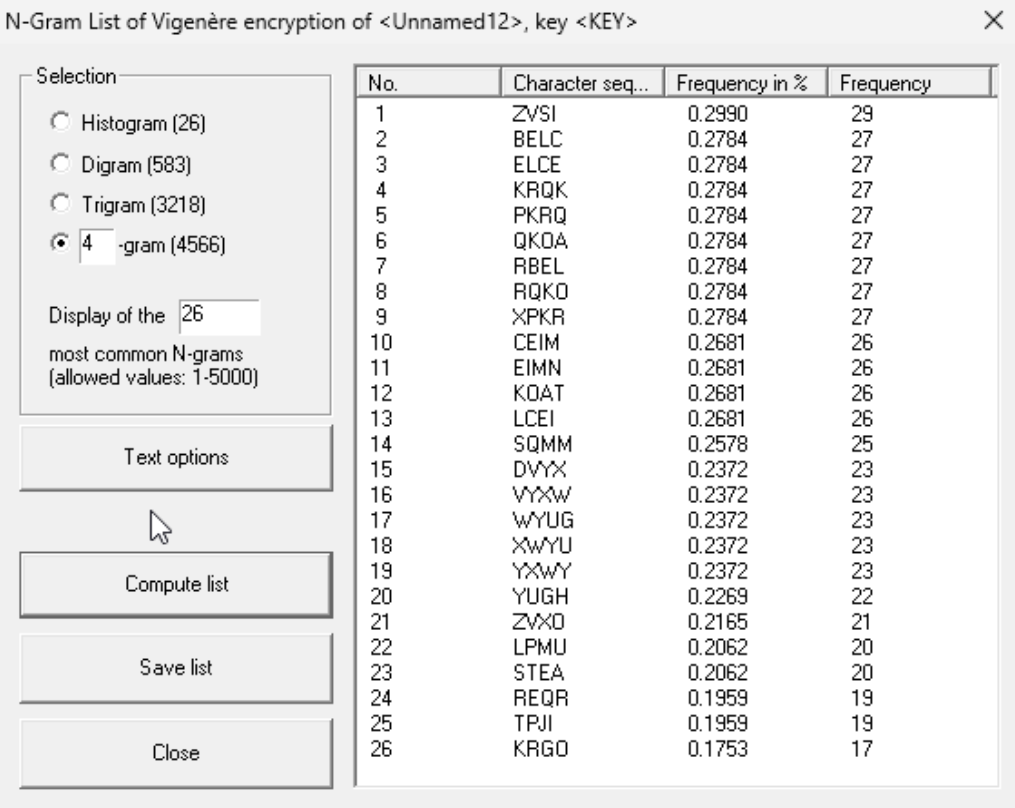

Permutation: Key: “KEY”
- English:
- Digram:
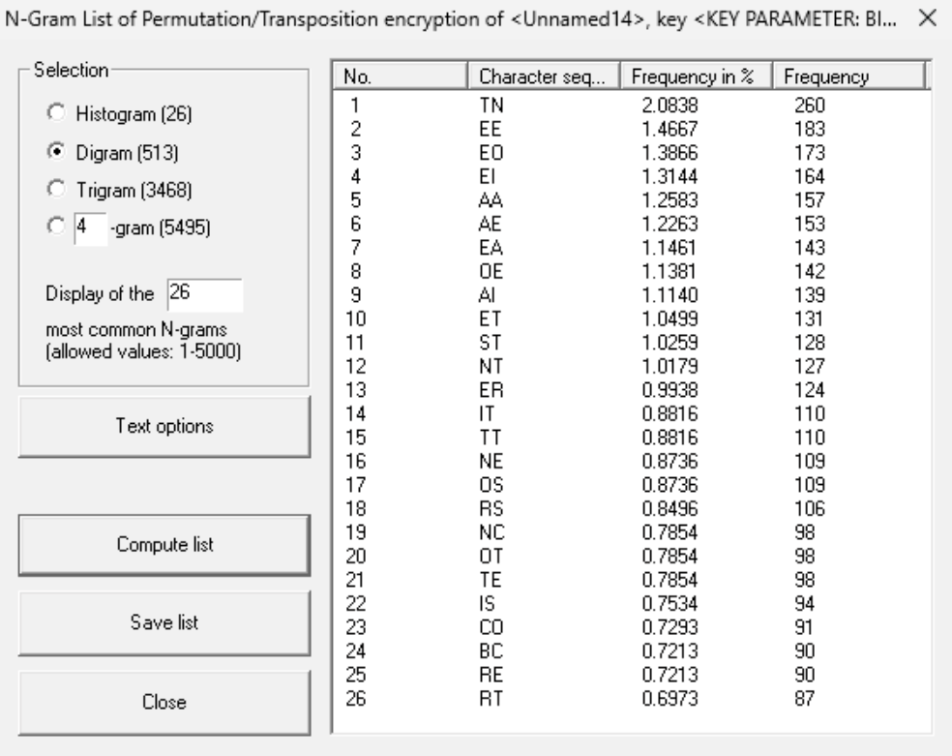
- Trigram:

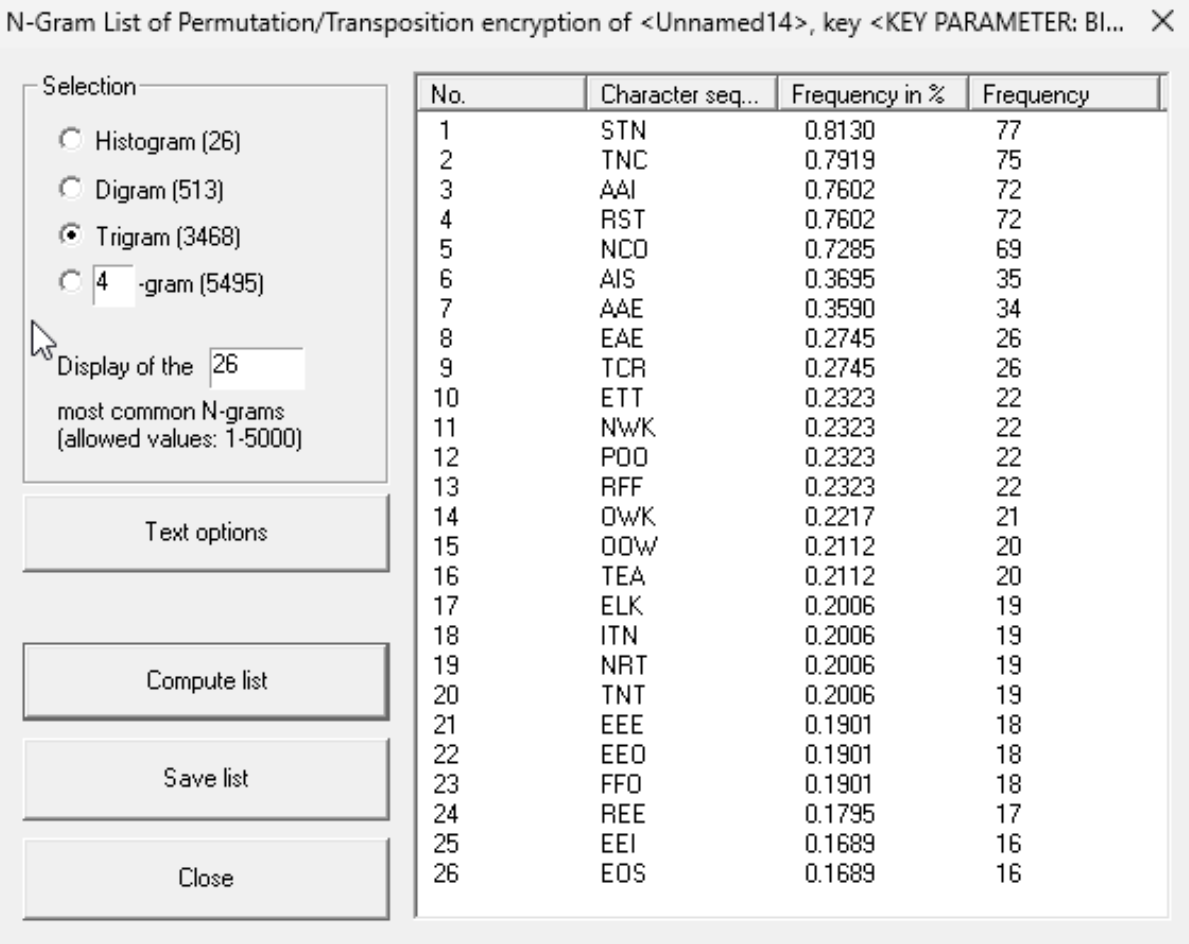

- 4-gram:
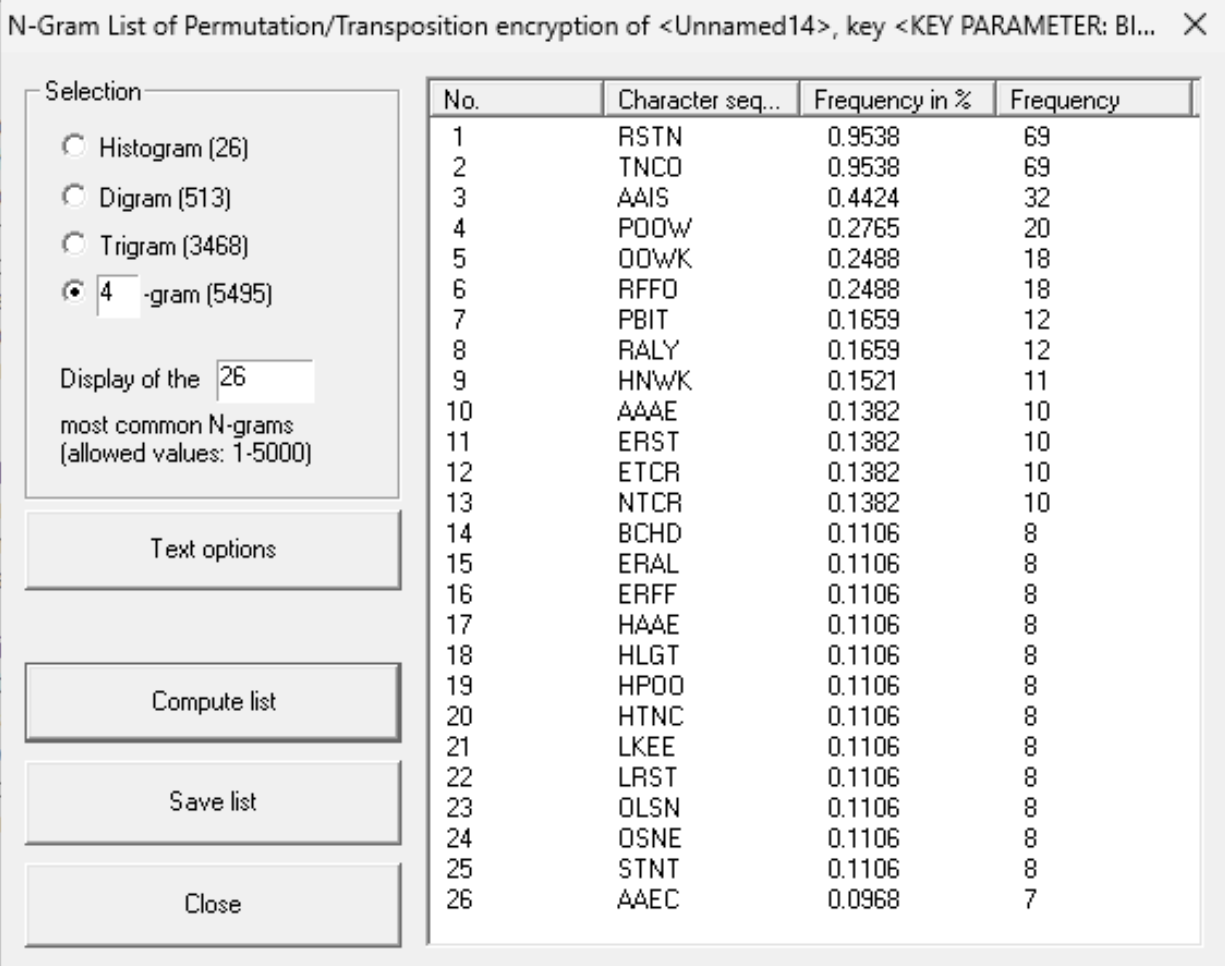

- Spanish:
- Digram:
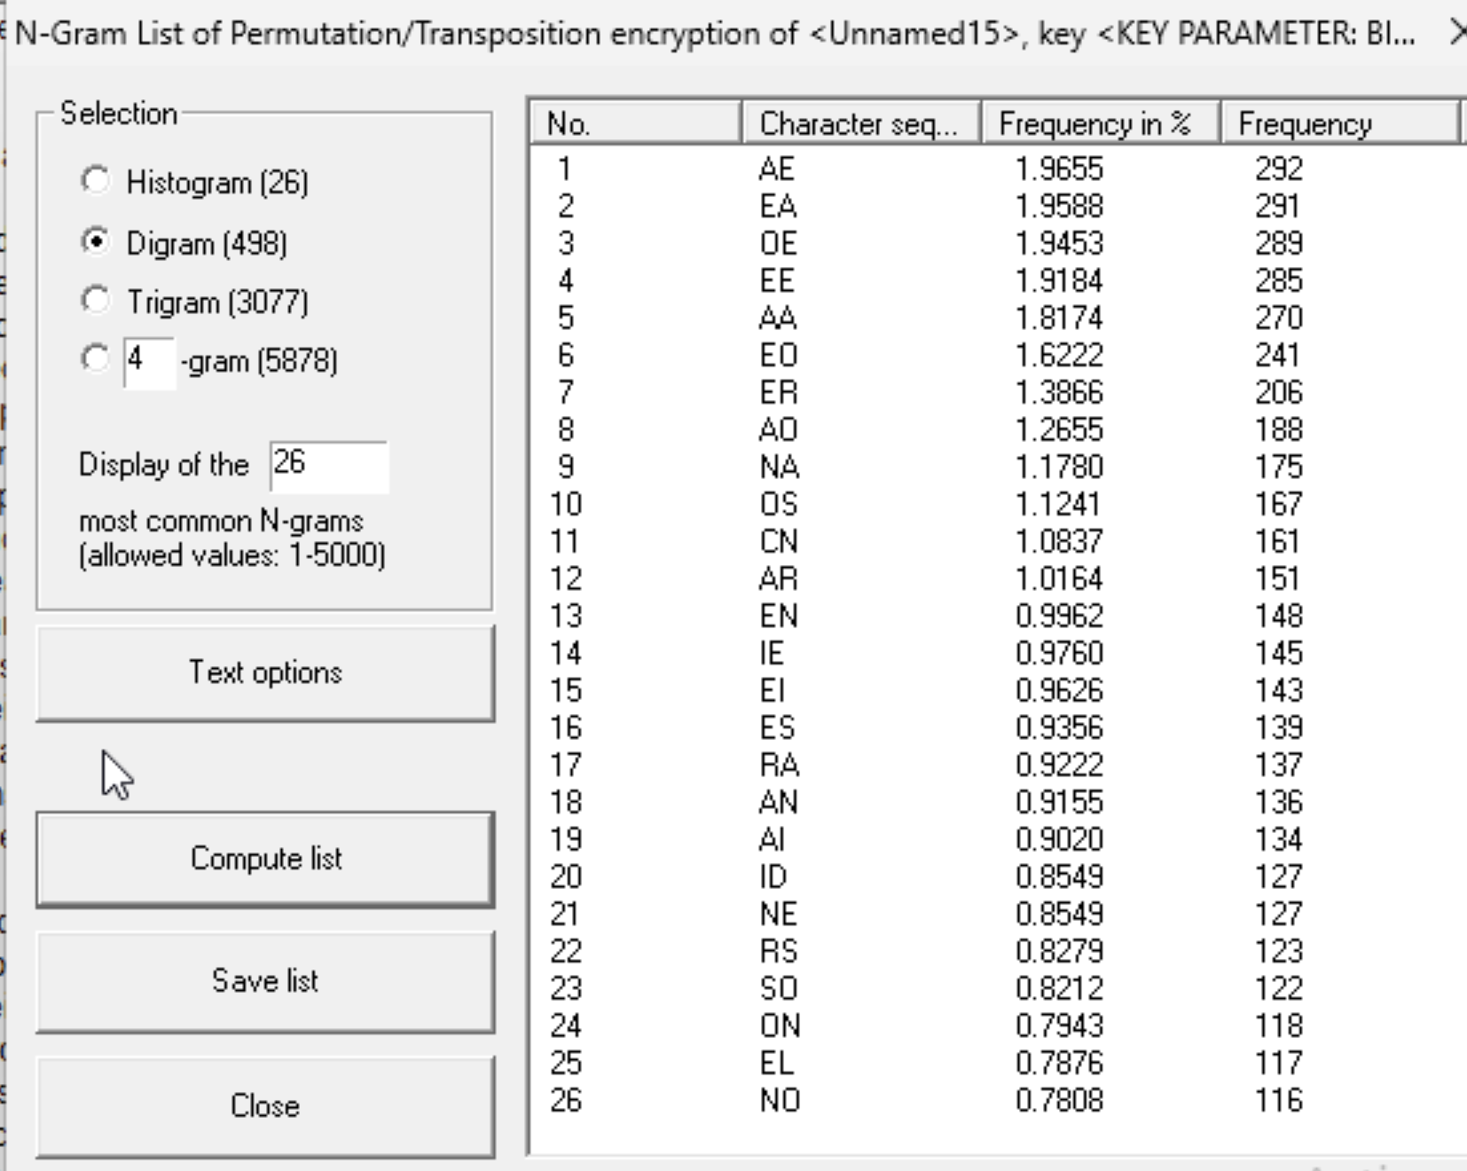

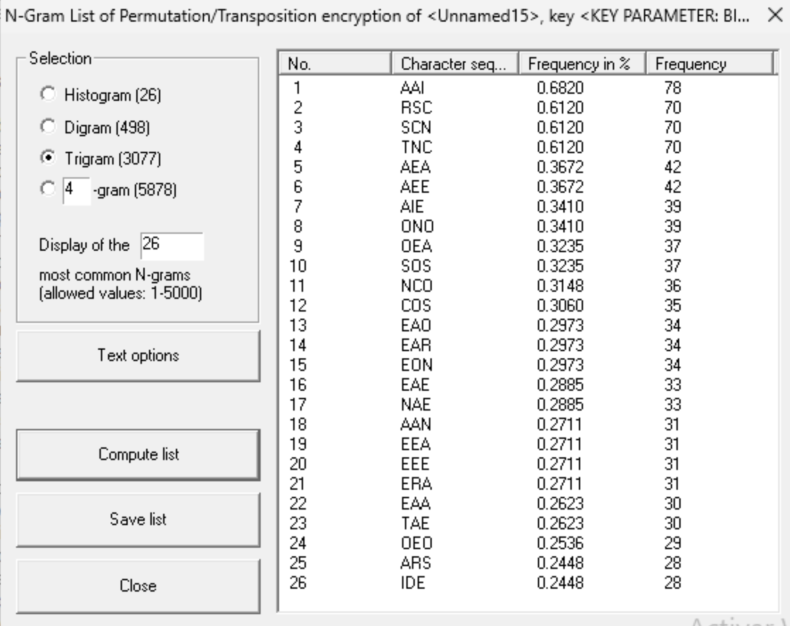
- Trigram:

- 4-gram:
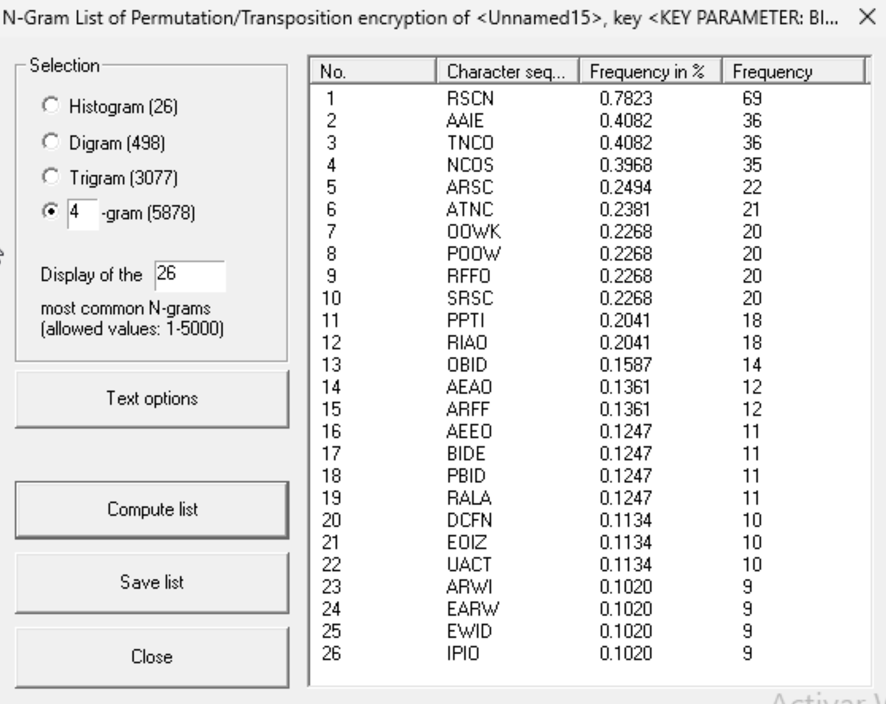

- Polish:
- Digram:
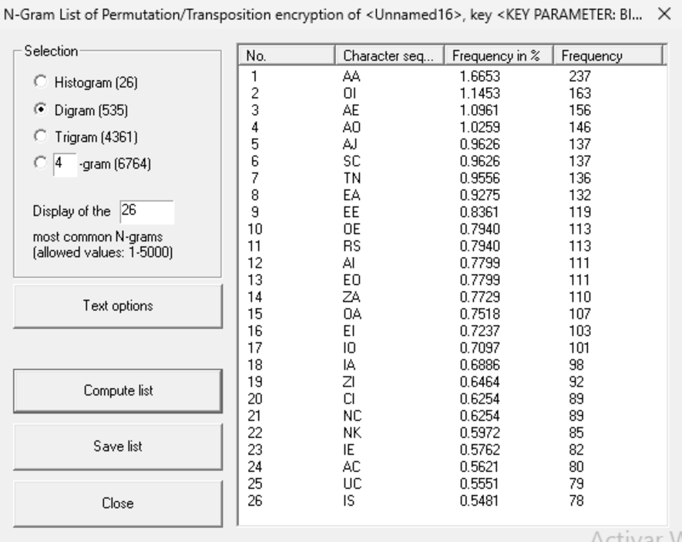

- Trigram:
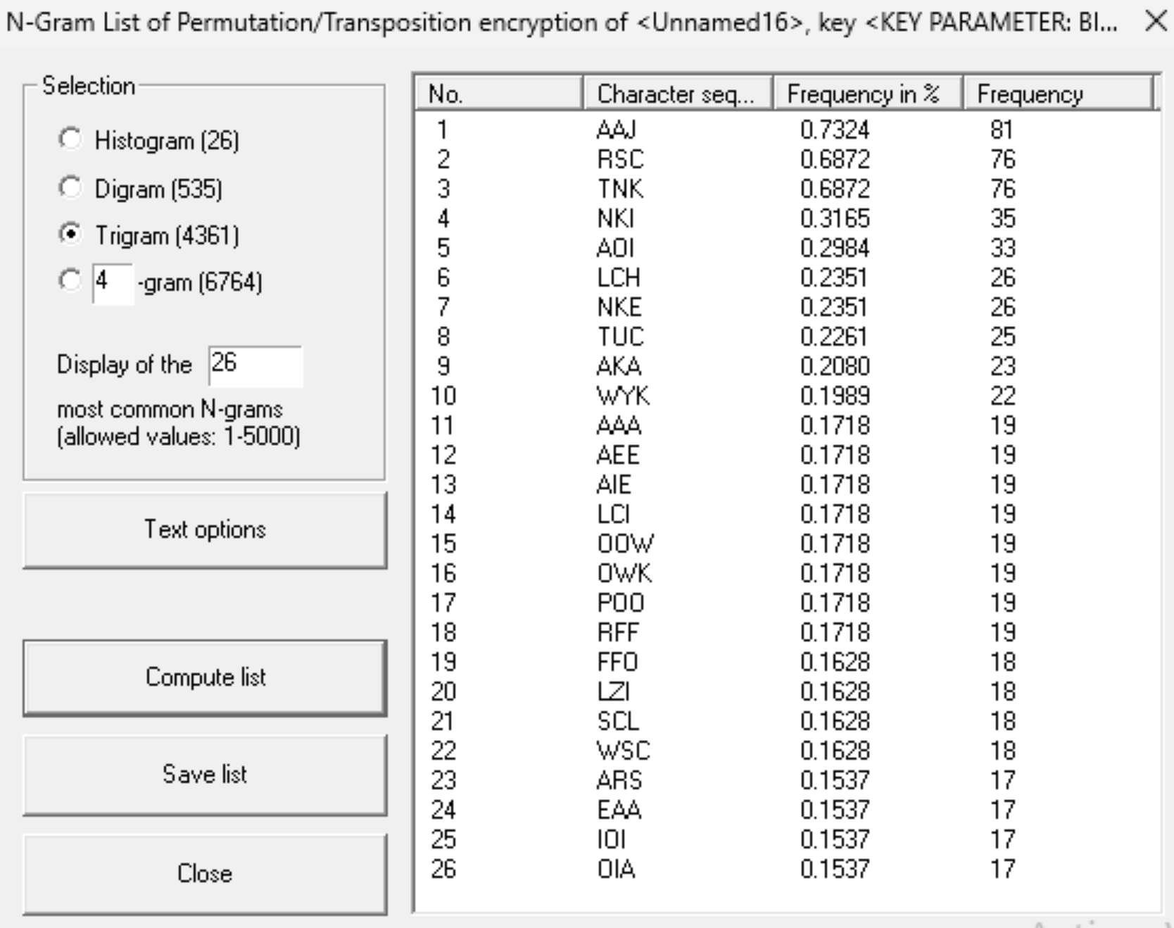

- 4-gram:
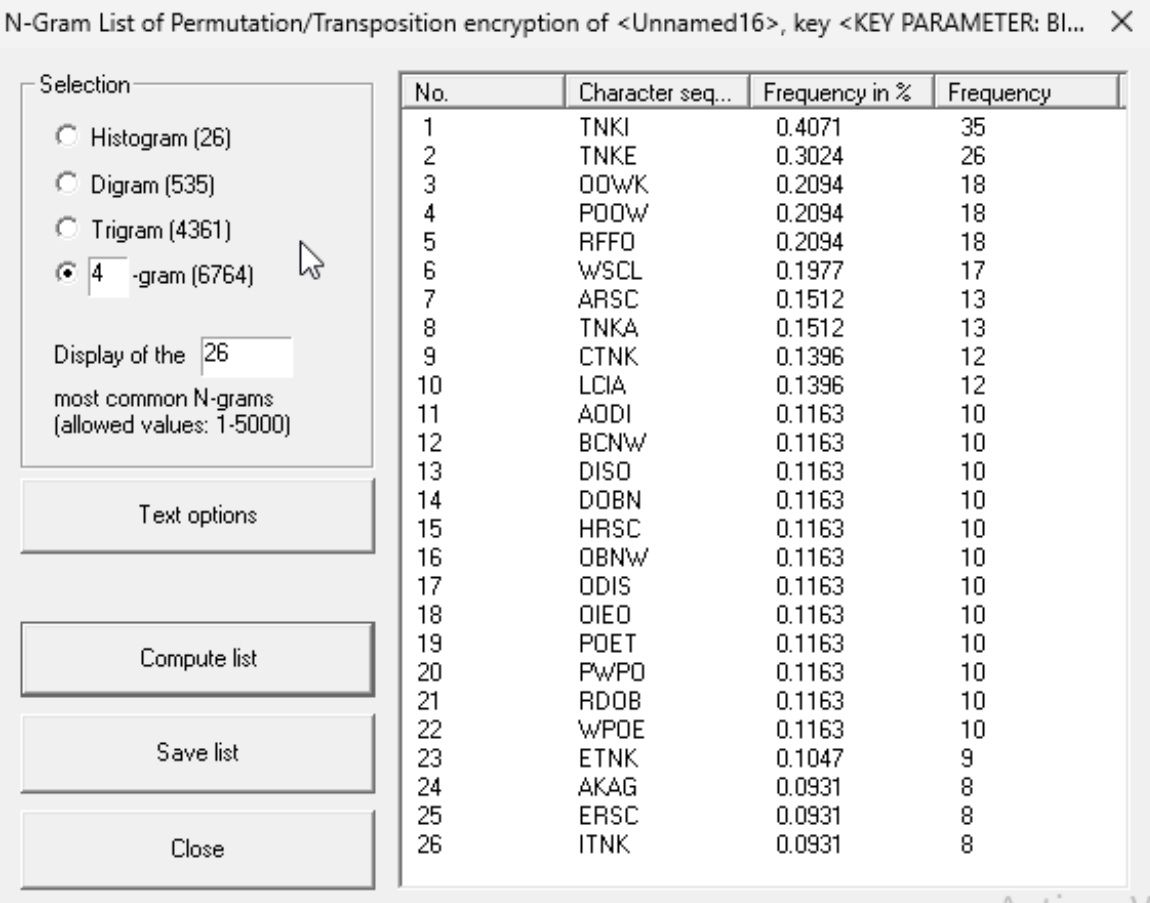

In the Caesar cipher, bigram and trigram distributions remained almost identical to those of the plaintext as it is a mono alphabetic substitution and the frequencies remain the same.
For Vigenère encryption, as larger is the Key, the frequencies will have a smaller difference between the.
The permutation cipher reduced the frequencies, as its transposition destroyed the positional correlations.

Analyze the autocorrelation values of the ciphertext obtained by encryption XOR and Vigenère algorithms for different password lengths:
I am using the English Plain text.
- Vigenère: Key:”KEY”
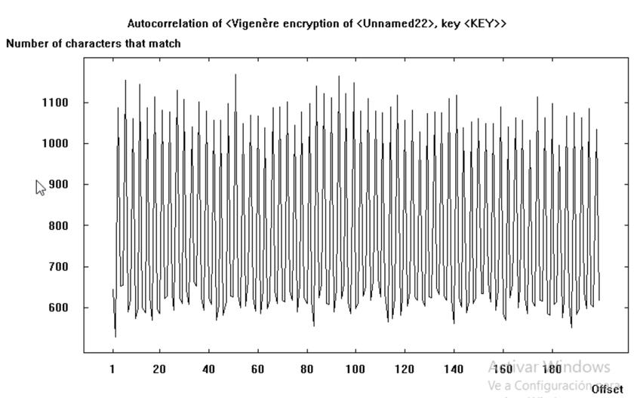
- Vigenère: Key:”LARGERKEY”
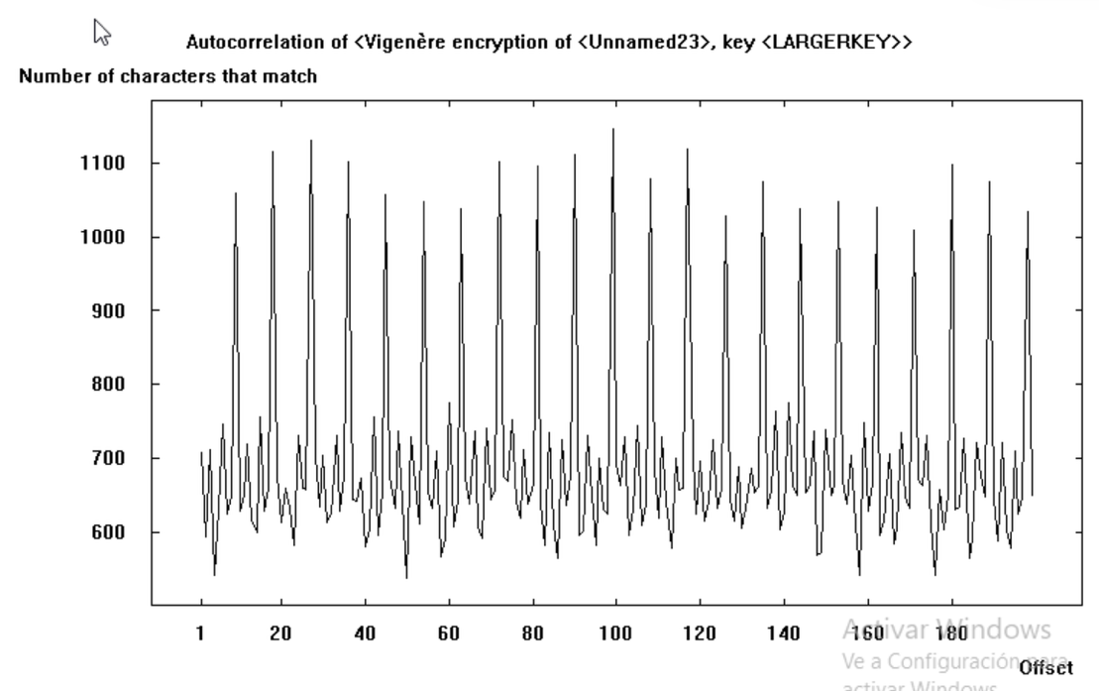

- Vigenère: Key: “THELARGESTKEYHERE”
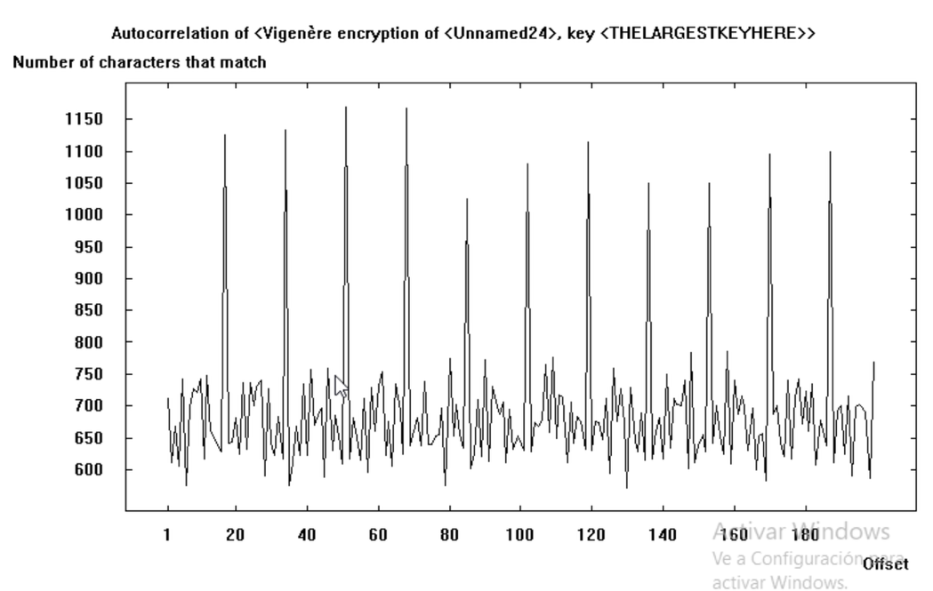
You can see for the Vigenère cypher a pattern between the length of the key and the separation between spikes. For short keys the spikes have a higher frequency and for larger ones a lower frequency of spikes.

- XOR: Key: 3F
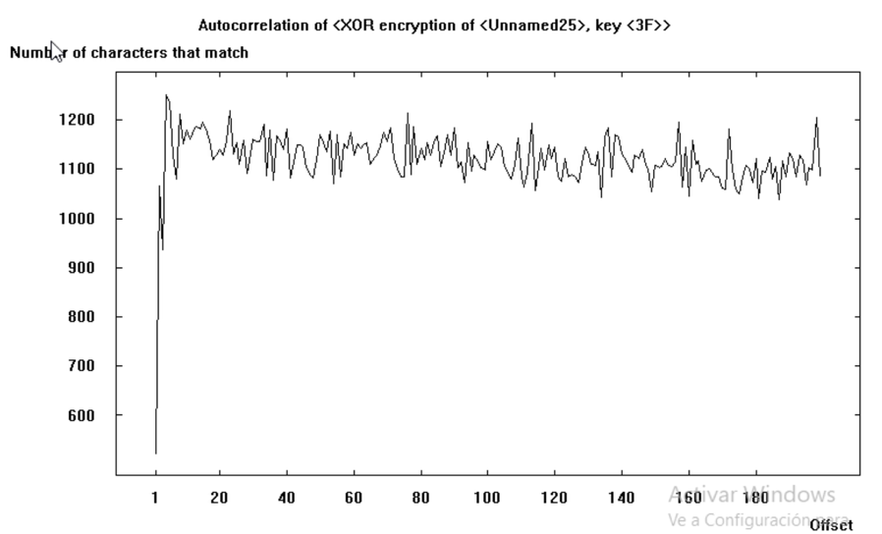

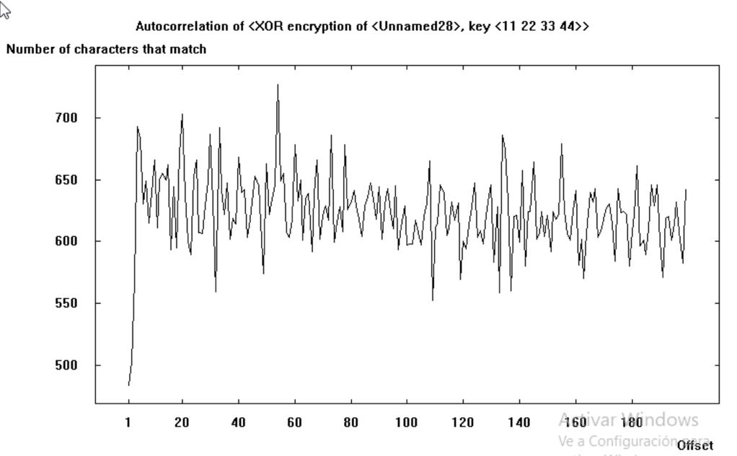
- XOR: Key: 11223344

- XOR: Key: 9AAFEE45981835FACB
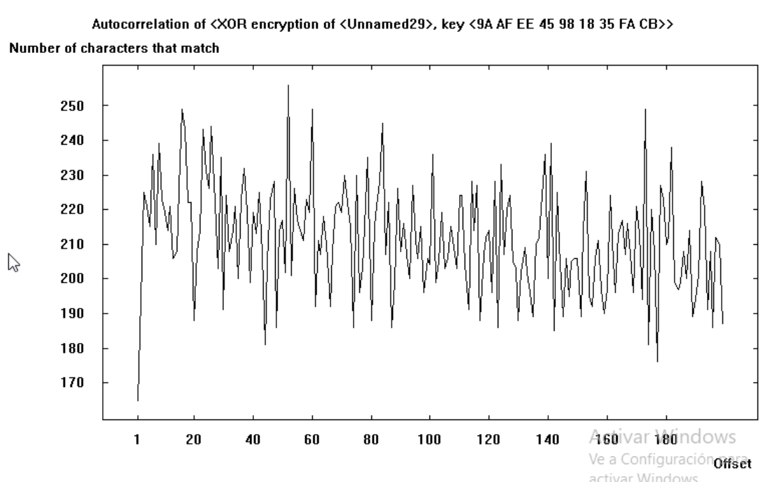
With the XOR algorithm we can see a negative correlation between the length of the Key and the number of characters that match in the autocorrection.

How do the observed parameters change?
As the encryption key length increases or as the cipher becomes more complex, all statistical parameters progressively approach those of a random sequence.
The entropy rises, meaning that the information content and unpredictability of the ciphertext increase. Histograms become flatter, showing that all symbols appear with nearly equal probability. N-gram distributions lose the characteristic patterns of natural language; common letter pairs or triplets vanish, and no linguistic structure remains. Finally, the autocorrelation curve becomes flat, indicating the absence of periodicity or repetition.
In general, higher key lengths and stronger algorithms destroy the statistical regularities of the plaintext, producing ciphertexts that are increasingly random and therefore more resistant to classical cryptanalysis.

How can the text analysis tools available in CrypTool be used to determine the encryption algorithm for a given ciphertext?
Each tool in Cryptool provides us with different information, such as:
- Histogram: Shows letter frequencies. A shifted histogram suggests a Caesar/shift or simple monoalphabetic substitution.
- N-grams (bigrams/trigrams): Frequent sequences point to common words/particles in the language and help recover substitution mappings or cribs.
- Autocorrelation: Periodic peaks reveal repeating-key ciphers (Vigenère, repeating XOR); the peak spacing estimates key length.
- Index of Coincidence / Kasiski / Friedman tests: Distinguish monoalphabetic vs polyalphabetic ciphers and give key-length estimates.
- Ciphertext-only solvers: Once you classify the family, run automated solvers (Caesar, Vigenère, substitution, columnar, ADFGVX, XOR, etc.) to recover keys/plaintext.

How can the text analysis tools available in the CrypTool program be used to determine the password used for encryption?
The general workflow has 4 steps:
- Classify the cipher using Histogram, IC, Autocorrelation, N-grams.
- Estimate key length / structure (Friedman, Kasiski, autocorrelation).
- Run targeted solver for that family (CrypTool has ciphertext-only modules).
- Validate candidate keys by decrypting and scoring the plaintext.

Analysis of delivered files:

Try to recognize which encryption algorithm has been used based on an analysis of the ciphertext program only. All cryptograms were created based on the same plaintext. Files 1_X.txt,..,:
The file 1 can be classified as a monoalphabetic substitution as the histogram shows a normal frequency in English language:
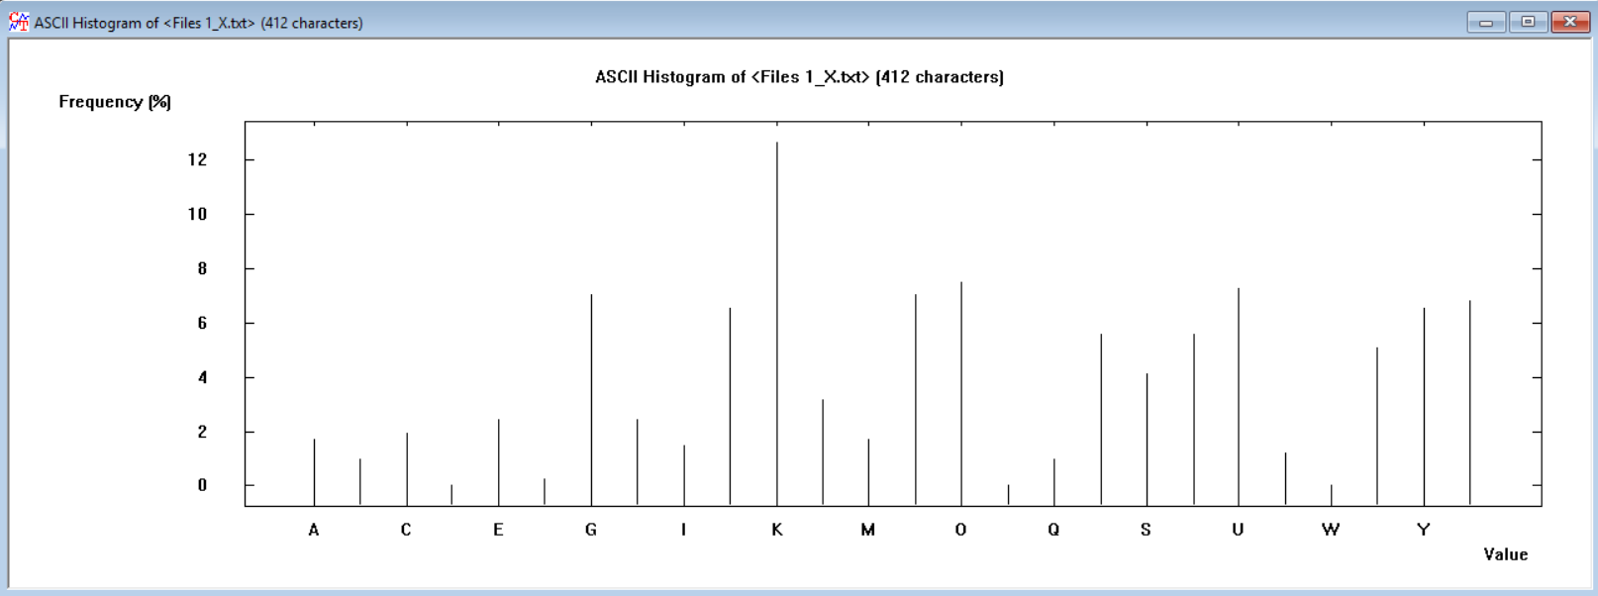

We can see also high frequencies in the diagram and trigram, meaning that the letters are substituted but not permutated:
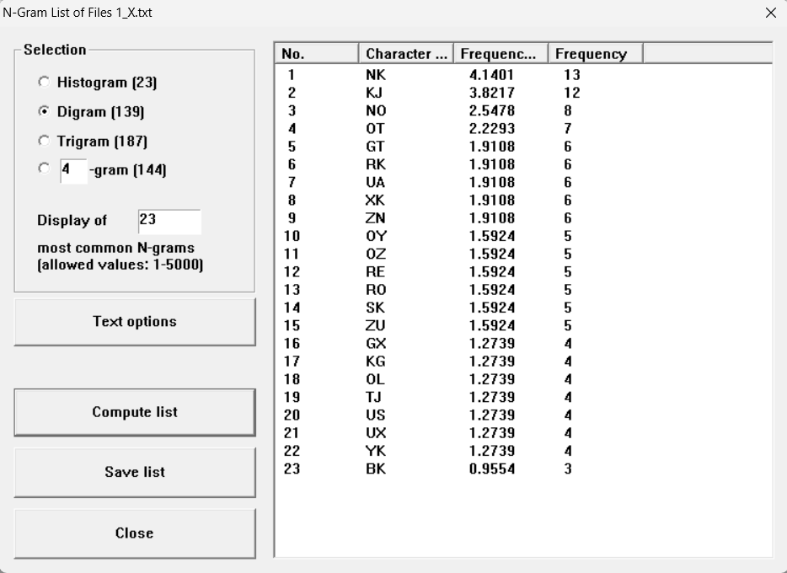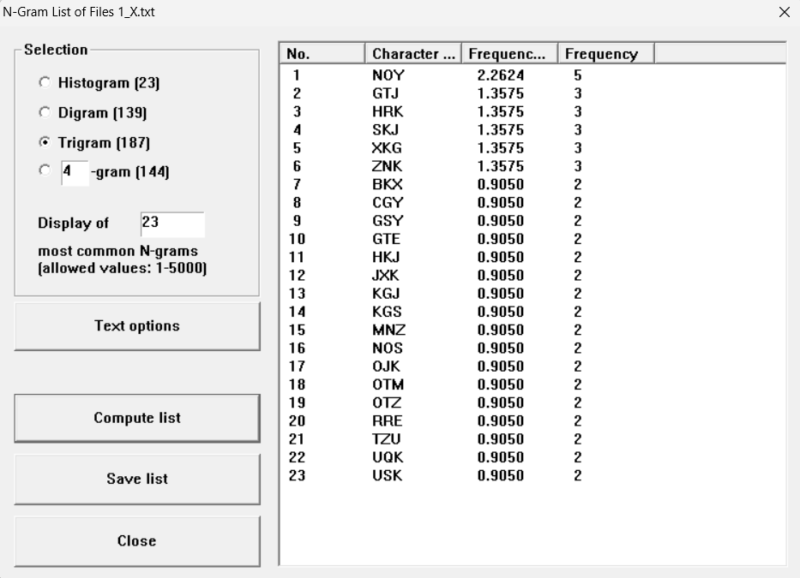
So, we try with deciphering it with Cesar/Vigenère (Key length 1) and the key is “G”:
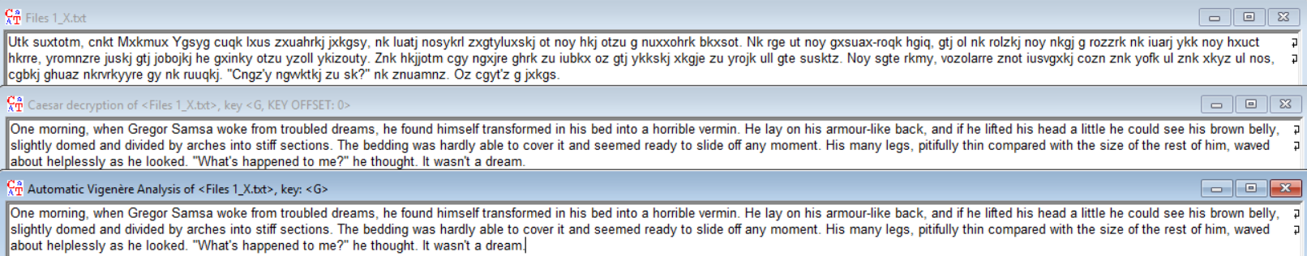
The decrypted text is: “One morning, when Gregor Samsa woke from troubled dreams, he found himself transformed in his bed into a horrible vermin. He lay on his armour-like back, and if he lifted his head a little he could see his brown belly, slightly domed and divided by arches into stiff sections. The bedding was hardly able to cover it and seemed ready to slide off any moment. His many legs, pitifully thin compared with the size of the rest of him, waved about helplessly as he looked. "What's happened to me?" he thought. It wasn't a dream.”

Try to decrypt by hand (using premises such as type algorithm, histogram, and other tools) or by using the automatic cipher-breaking option (Analysis - > Symmetric Encryption (Classic) -> Ciphertext-only) encryption programs placed in files 2_x.txt, ...:
The automatic Vigenère analysis showed that the key length was 7, if you increased by 1 as there is an small error, you could see that finally the text is decrypted with the key EMMANUEL.

The histogram more randomness than in file 1: 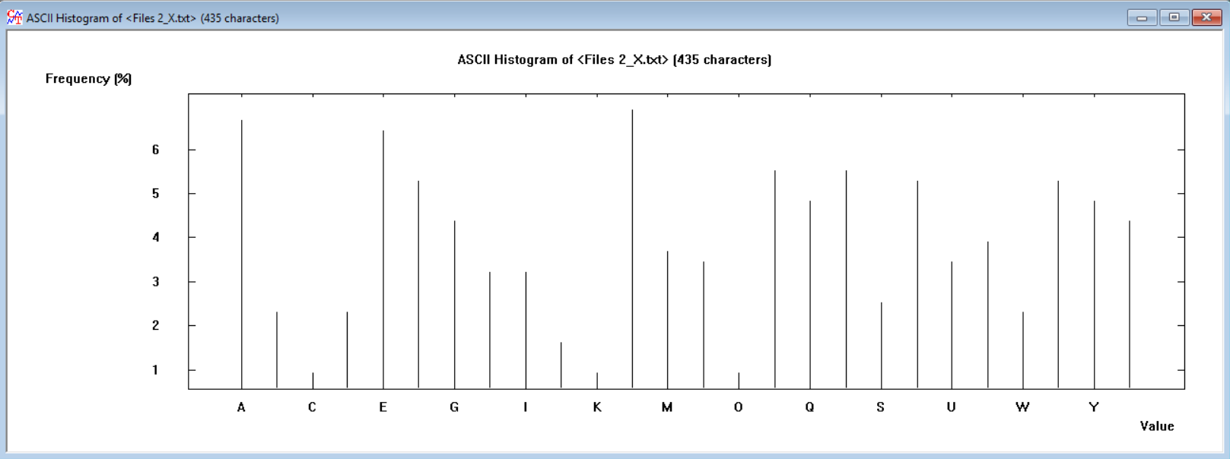
In the autocorrelation we don’t see a pattern discarding some algorithms:
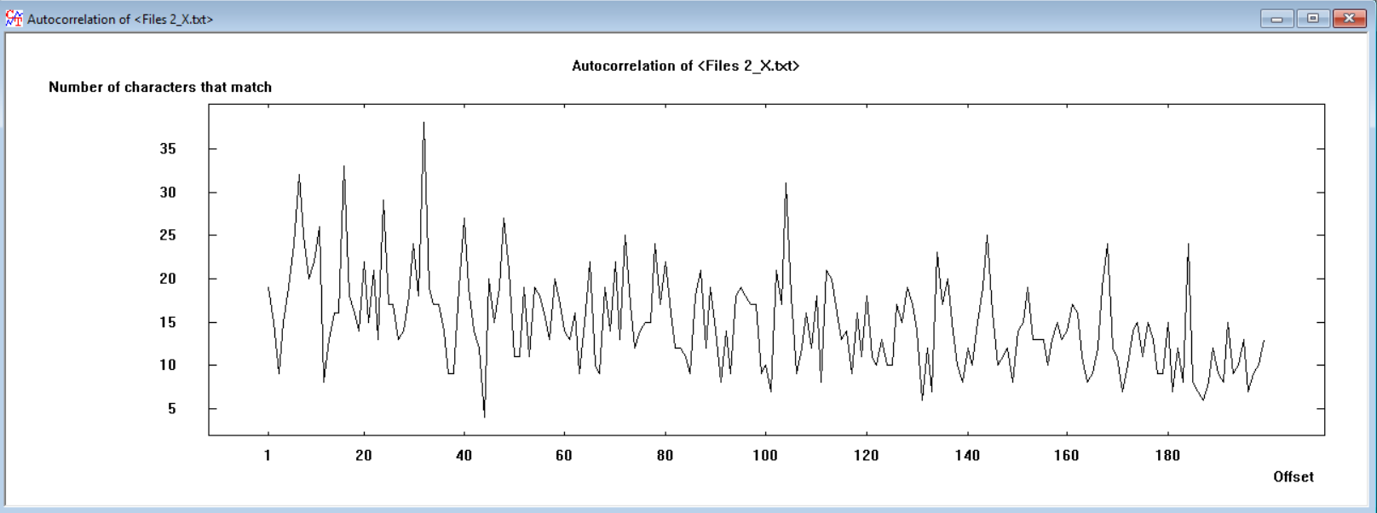
The decrypted text is:
“His room, a proper human room although a little too small, lay peacefully between its four familiar walls. A collection of textile samples lay spread out on the table - Samsa was a travelling salesman - and above it there hung a picture that he had recently cut out of an illustrated magazine and housed in a nice, gilded frame. It showed a lady fitted out with a fur hat and fur boa who sat upright, raising a heavy fur muff that covered the whole of her lower arm towards the viewer. Gregor then turned to look out the window at the dull weather.”

Recognize what encryption algorithm was used, and then try to decrypt the provided ciphertext programs. Files: 3_x.txt, ...:
This file 3 is clearly encrypted with playfair as in it histogram there is no appearance of the letter J also the division of the text in 2 character blocks, meaning it was encrypted with 5x5 matrix.
It must be a text from: Franz Kafka’s The Metamorphosis (Die Verwandlung), originally written in German (first published 1915). As the rest of the texts.
Histogram:
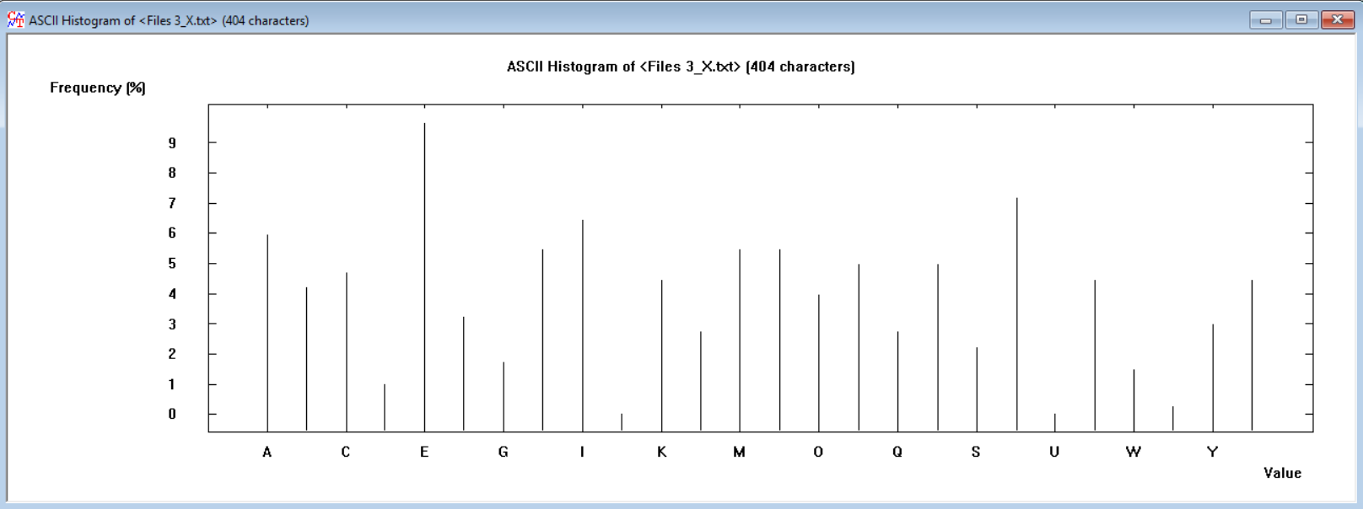
Digram:
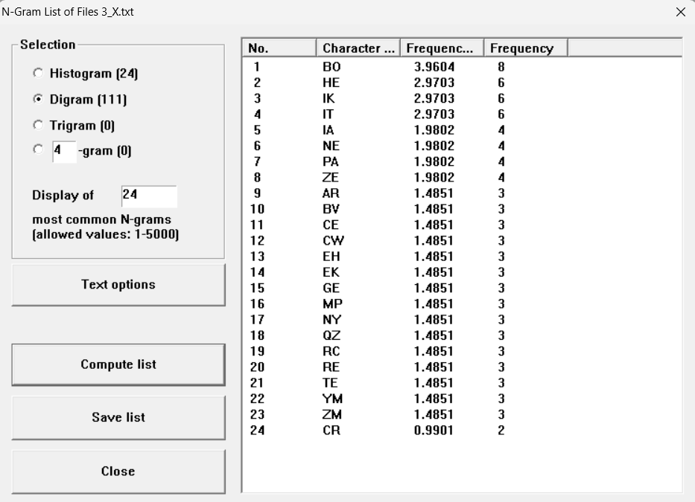

What does the strength of the algorithm depend on?
The strength of an algorithm depends on:
- Key secrecy (known plaintext/ciphertext): even if an attacker knows the algorithm and sees example message pairs, they still can’t realistically figure out your secret key.
- Avalanche (confusion + diffusion): a tiny change in the key or the message makes the entire encrypted output change wildly and unpredictably.
- All-or-nothing: a wrong key doesn’t reveal bits of the message; it just produces useless, random-looking data.
- (Asymmetric) Key-pair infeasibility: having one key (e.g., the public key) and the algorithm shouldn’t allow anyone to compute the matching private key.

How can the encryption strength be increased for known ciphers?
Some general rules for increasing strength in a cypher are:
- Use long, truly random keys and never reuse them.
- Multi cypher: combine substitution + transposition and repeat with different keys.
- Flatten frequencies: polyalphabetic keys, homophones, padding.
- For stream/XOR/byte-addition -> derive keystream from a secure PRNG (Pseudorandom Number Generator) and never reuse it.
- OTP is perfect only if key = message length, truly random, secret, and never reused.
- Increase block/matrix size for Hill, use random key tables for Playfair and treat Caesar/Atbash as obsolete.

